A PROJECT REPORT ON

Online Survey Tool

Submitted to ******************** University for the partial fulfillment of the Requirement for the

Award of Degree for
***********Course Name*************

Done By

Mr. /Miss *********************************************

**************Institute of Management and Computer Science

CERTIFICATE

This is to certify that Mr., /Miss ****************** bearing Roll
No. ********************** have developed software project
Titled **************** For ********************* Software
Solutions as Partial fulfillment for the award of the Degree of
**************

Head of the Department Principal
******College Name******

External

ACKNOWLEDGEMENT

At every outset I express my gratitude to almighty lord for showering his grace and blessings upon me to complete this project.
Although our name appears on the cover of this book, many people had contributed in some form or the other form to this project Development. We could not done this project without the assistance or support of each of the following we thank you all.
I wish to place on my record my deep sense of gratitude to my project guide, Mr. ******, ***** Software Solutions, for his constant motivation and valuable help through the project work. Express my gratitude to Mr. ******, Director of ******* Institute of Management & Computer Sciences for his valuable suggestions and advices throughout the ***** course. I also extend my thanks to other Faculties for their Cooperation during my Course.
Finally I would like to thank my friends for their cooperation to complete this project.

*******Your Name*********

ABSTRACT

Objective:

Nowadays Survey and Analysis is an essential tool of business. A flexible survey tool that can be configured for any type of comments and can be published in a few minutes time is need of the hour. Here we propose a project that can create publish and conduct analysis on survey/review data effectively.
This project is a rating stars based on the score you assign. It can also calculate and output overall ratings you have assigned.

Preface
Table of Contents
- INTRODUCTION
  - INTRODUCTION TO PROJECT
  - PURPOSE OF THE SYSTEM
  - PROBLEMS IN EXISTING SYSTEM
  - SOLUTION OF THESE PROBLEMS
  - PROPOSED SYSTEM
- SYSTEM ANALYSIS
  - INTRODUCTION
  - ANALYSIS MODEL
  - STUDY OF THE SYSTEM
  - SYSTEM REQUIREMENT SPECIFICATIONS
  - INPUT AND OUTPUT
  - PROCESS MODULES USED WITH JUSTIFICATION
  - SCOPE OF THE SYSTEM
  - CONTEXT LEVEL DIAGRAM
- FEASIBILITY REPORT
  - TECHNICAL FEASIBILITY
  - OPERATIONAL FEASIBILITY
  - ECONOMICAL FEASIBILTY
- SOFTWARE REQUIREMENT SPECIFICATIONS
  - FUNCTIONAL REQUIREMENTS
  - PERFORMANCE REQUIREMENTS
- SELECTED SOFTWARE
  - INTRODUCTION TO .NET FRAME WORK
  - ASP.NET
  - C#.NET
  - SQL SERVER
- SYSTEM DESIGN
  - INTRODUCTION
  - NORMALIZATION
  - E-R DIAGRAM
  - DATA FLOW DIAGRAMS
  - DATA DICTIONARY
  - UML DIAGRAMS
- OUTPUT SCREENS
- SYSTEM TESTING AND IMPLEMENTATION
  - INTRODUCTION
  - STRATEGIC APPROACH OF SOFTWARE TESTING
  - UNIT TESTING
- SYSTEM SECURITY
  - INTRODUCTION
  - SECURITY IN SOFTWARE
- CONCLUSION
- FUTURE ENHANCEMENTS
- BIBLOGRAPHY

  - INTRODUCTION TO PROJECT
Nowadays Survey and Analysis is an essential tool of business. A flexible survey tool that can be configured for any type of comments and can be published in a few minutes time is need of the hour. Here we propose a project that can create publish and conduct analysis on survey/review data effectively.
This project is a rating stars based on the score you assign. It can also calculate and output overall ratings you have assigned.

  - PURPOSE OF THE PROJECT
- Websites are great. They're an easy way for one person to reach thousands of people with useful information. Here we are developing this application for Online Survey Tool. Online Survey Tool that can be configured for any type of comments and can be published in a few minutes time is need of the hour.
- In this application we are providing No of Product Type to users. But if user wants to get this Product He can give his own comments on product details. He can also view others comments assigned/given to the particular product details.

  - PROBLEM IN EXISTING SYSTEM
The existing has following drawbacks.

- It is less user-friendly.
- It is having lots of manual work (Manual system does not mean that you are working with pen and paper, it also include working on spread sheets and other simple software's).
- The present system is very less secure.
- It is unable to generate different kinds of report.
- Multi-user environment is not provided.
- Accuracy not guaranteed.

  - PROPOSED SYSTEM
The development of this new system contains the following activities, which try to automate the entire process keeping in the view of database integration approach. The system makes the overall project management much easier and flexible. The user information files can be stored in centralized database which can be maintained by the system. This can give the good security for user information because data is not in client machine. Authentication is provided for this application only registered members can access. There is no risk of data management at any level while the project development is under process. Report generation is provided to generate different kind of reports. The system has an interface of grievance handling and status reporting to user.

SYSTEM ANALYSIS

2.1 INTRODUCTION
After analyzing the requirements of the task to be performed, the next step is to analyze the problem and understand its context. The first activity in the phase is studying the existing system and other is to understand the requirements and domain of the new system. Both the activities are equally important, but the first activity serves as a basis of giving the functional specifications and then successful design of the proposed system. Understanding the properties and requirements of a new system is more difficult and requires creative thinking and understanding of existing running system is also difficult, improper understanding of present system can lead diversion from solution.
2.2 ANALYSIS MODEL
Mainly there are four phases in the "Spiral Model":
- Planning
- Evolutions
- Risk Analysis
- Engineering
Software Development India
Planning: In this phase, the aims, option and constraints of the project are determined and are documented. The aims and other specifications are fixed so as to determine the strategies/approaches to go after during the project life cycle.
Risk Analysis: It is the most significant phase of "Spiral Model". In this phase the entire possible option that are available and helpful in developing a cost efficient project are analyzed and strategies are determined to employ the available resources. This phase has been added particularly so as to recognize and resolve all the possible risks in the project Citizen Card System. If any indication shows some uncertainty in needs, prototyping may be utilized to continue with the obtainable data and discover out possible software development solution so as to deal with the potential modification in the needs.
Engineering: In this phase, the specific software development of the project is worked out. The output of developed of modules by modules is passed through all the phases iteratively so as to obtain development in the same.
Customer Evaluation: In this phase, before releasing the developed product, the product is passed on to the customer so as to obtain customer’s views and suggestions and if some is left or the desire result is not achieved then all the needs will be identified and resolve all the possible problems/errors in the Farmers Buddy. One can compare it from the TESTING phase.
The spiral model, illustrated in below figure, combines the iterative nature of prototyping with the controlled and systematic aspects of the waterfall model, therein providing the potential for rapid development of incremental versions of the software. In this model the software is developed in a series of incremental releases with the early stages being either paper models or prototypes. Later iterations become increasingly more complete versions of the product.
Depending on the model it may have 3-6 task regions our case will consider a ‘6-task region’ model.
These regions are:
- The User communication task – to establish effective communication between developer and User.
- The planning task – to define resources, time lines and other project related information..
- The risk analysis task – to assess both technical and management risks.
- The engineering task – to build one or more representations of the application.
- The construction and release task – to construct, test, install and provide user support (e.g., documentation and training).
- The User evaluation task – to obtain customer feedback based on the evaluation of the software representation created during the engineering stage and implemented during the install stage.
The evolutionary process begins at the centre position and moves in a clockwise direction. Each traversal of the spiral typically results in a deliverable. For example, the first and second spiral traversals may result in the production of a product specification and a prototype, respectively. Subsequent traversals may then produce more sophisticated versions of the software.
An important distinction between the spiral model and other software models is the explicit consideration of risk. There are no fixed phases such as specification or design phases in the model and it encompasses other process models. For example, prototyping may be used in one spiral to resolve requirement uncertainties and hence reduce risks. This may then be followed by a conventional waterfall development.

- Note that each passage through the planning stage results in an adjustment to the project plan.
- Each of the regions is populated by a set of work tasks called a task set that are adapted to characteristics of the project to be undertaken. For small projects the number of tasks and their formality is low. Conversely, for large projects the reverse is true.
Advantages of the Spiral Model
- The spiral model is a realistic approach to the development of large-scale software products because the software evolves as the process progresses. In addition, the developer and the client better understand and react to risks at each evolutionary level.
- The model uses prototyping as a risk reduction mechanism and allows for the development of prototypes at any stage of the evolutionary development.
- It maintains a systematic stepwise approach, like the classic life cycle model, but incorporates it into an iterative framework that more reflect the real world.
- If employed correctly, this model should reduce risks before they become problematic, as consideration of technical risks are considered at all stages.
Disadvantages of the Spiral Model
- Demands considerable risk-assessment expertise
- It has not been employed as much proven models (e.g. the WF model) and hence may prove difficult to ‘sell’ to the client that this model is controllable and efficient.

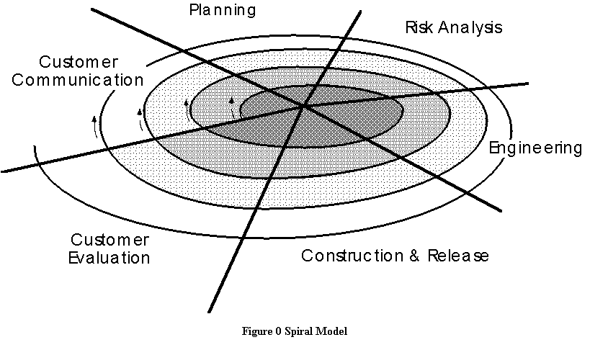
2. PROCESS MODEL
The process model is typically used in structured analysis and design methods. Also called a data flow diagram (DFD), it shows the flow of information through a system. Each process transforms inputs into outputs.
The model generally starts with a context diagram showing the system as a single process connected to external entities outside of the system boundary. This process explodes to a lower level DFD that divides the system into smaller parts and balances the flow of information between parent and child diagrams. Many diagram levels may be needed to express a complex system. Primitive processes, those that don't explode to a child diagram, are usually described in a connected textual specification.
2.3 STUDY OF THE SYSTEM
Three tactics to use for giving a system design a future orientation:
- Build redundancy into the current system.
- Maintain a future file on every system.
- Develop documentation.
Logical design
- Produces a system blueprint
- General rather than technical format
Physical design
- Converts the blueprint into the specific detail required to construct the code
- Includes specifying complete descriptions of files, input, and output.
In the flexibility of uses the interface has been developed a graphics concepts in mind, associated through a browser interface. The GUI’s at the top level has been categorized as follows:
- Administrative User Interface Design
- The Operational and Generic User Interface Design (The Citizens and Guests are comes under this category.)
The administrative user interface concentrates on the consistent information that is practically, part of the organizational activities and which needs proper authentication for the data collection. The Interface helps the administration with all the transactional states like data insertion, data deletion, and data updating along with executive data search capabilities.
The operational and generic user interface helps the users upon the system in transactions through the existing data and required services. The operational user interface also helps the ordinary users in managing their own information helps the ordinary users in managing their own information in a customized manner as per the assisted flexibilities.

2.8 CONTEXT DIAGRAM:
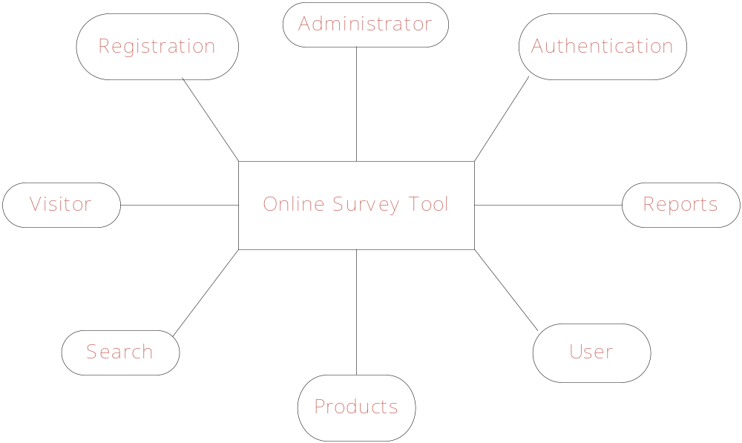

FEASUBILITY STUDY

Preliminary investigation examine project feasibility, the likelihood the system will be useful to the organization. The main objective of the feasibility study is to test the Technical, Operational and Economical feasibility for adding new modules and debugging old running system. All system is feasible if they are unlimited resources and infinite time. There are aspects in the feasibility study portion of the preliminary investigation:
- Technical Feasibility
- Operational Feasibility
- Economical Feasibility

3.1. TECHNICAL FEASIBILITY
Technical Feasibility centers on the existing computer system hardware, software, etc. and to some extent how it can support the proposed addition. This involves financial considerations to accommodate technical enhancements. Technical support is also a reason for the success of the project. The techniques needed for the system should be available and it must be reasonable to use. Technical Feasibility is mainly concerned with the study of function, performance, and constraints that may affect the ability to achieve the system. By conducting an efficient technical feasibility we need to ensure that the project works to solve the existing problem area.
Since the project is designed with ASP.NET with C# as Front end and SQL Server 2000 as Back end, it is easy to install in all the systems wherever needed. It is more efficient, easy and user-friendly to understand by almost everyone. Huge amount of data can be handled efficiently using SQL Server as back end. Hence this project has good technical feasibility
3.2. OPERATIONAL FEASIBILITY
People are inherently instant to change and computers have been known to facilitate change. An estimate should be made to how strong a reaction the user staff is likely to have towards the development of the computerized system.
The staff is accustomed to computerized systems. These kinds of systems are becoming more common day by day for evaluation of the software engineers. Hence, this system is operationally feasible. As this system is technically, economically and operationally feasible, this system is judged feasible.
3.3. ECONOMICAL FEASIBILITY

The role of interface design is to reconcile the differences that prevail among the software engineer’s design model, the designed system meet the end user requirement with economical way at minimal cost within the affordable price by encouraging more of proposed system. Economic feasibility is concerned with comparing the development cost with the income/benefit derived from the developed system. In this we need to derive how this project will help the management to take effective decisions.

Economic Feasibility is mainly concerned with the cost incurred in the implementation of the software. Since this project is developed using ASP.NET with C# and SQL Server which is more commonly available and even the cost involved in the installation process is not high.

Similarly it is easy to recruit persons for operating the software since almost all the people are aware of ASP.NET with C# and SQL Server. Even if we want to train the persons in these area the cost involved in training is also very less. Hence this project has good economic feasibility.

The system once developed must be used efficiently. Otherwise there is no meaning for developing the system. For this a careful study of the existing system and its drawbacks are needed. The user should be able to distinguish the existing one and proposed one, so that one must be able to appreciate the characteristics of the proposed system, the manual one is not highly reliable and also is considerably fast. The proposed system is efficient, reliable and also quickly responding.

SOFTWARE REQUIREMENT SPECIFICATION

SELECTED SOFTWARE

5.1 INTRODUCTION TO .NET FRAMEWORK
The Microsoft .NET Framework is a software technology that is available with several Microsoft Windows operating systems. It includes a large library of pre-coded solutions to common programming problems and a virtual machine that manages the execution of programs written specifically for the framework. The .NET Framework is a key Microsoft offering and is intended to be used by most new applications created for the Windows platform.

The pre-coded solutions that form the framework's Base Class Library cover a large range of programming needs in a number of areas, including user interface, data access, database connectivity, cryptography, web application development, numeric algorithms, and network communications. The class library is used by programmers, who combine it with their own code to produce applications.

Programs written for the .NET Framework execute in a software environment that manages the program's runtime requirements. Also part of the .NET Framework, this runtime environment is known as the Common Language Runtime (CLR). The CLR provides the appearance of an application virtual machine so that programmers need not consider the capabilities of the specific CPU that will execute the program. The CLR also provides other important services such as security, memory management, and exception handling. The class library and the CLR together compose the .NET Framework.

Principal design features

Interoperability
Because interaction between new and older applications is commonly required, the .NET Framework provides means to access functionality that is implemented in programs that execute outside the .NET environment. Access to COM components is provided in the System.Runtime.InteropServices and System.EnterpriseServices namespaces of the framework; access to other functionality is provided using the P/Invoke feature.
Common Runtime Engine

The Common Language Runtime (CLR) is the virtual machine component of the .NET framework. All .NET programs execute under the supervision of the CLR, guaranteeing certain properties and behaviors in the areas of memory management, security, and exception handling.

Base Class Library

The Base Class Library (BCL), part of the Framework Class Library (FCL), is a library of functionality available to all languages using the .NET Framework. The BCL provides classes which encapsulate a number of common functions, including file reading and writing, graphic rendering, database interaction and XML document manipulation.
Simplified Deployment
Installation of computer software must be carefully managed to ensure that it does not interfere with previously installed software, and that it conforms to security requirements. The .NET framework includes design features and tools that help address these requirements.

Security

The design is meant to address some of the vulnerabilities, such as buffer overflows, that have been exploited by malicious software. Additionally, .NET provides a common security model for all applications.

Portability

The design of the .NET Framework allows it to theoretically be platform agnostic, and thus cross-platform compatible. That is, a program written to use the framework should run without change on any type of system for which the framework is implemented. Microsoft's commercial implementations of the framework cover Windows, Windows CE, and the Xbox 360. In addition, Microsoft submits the specifications for the Common Language Infrastructure (which includes the core class libraries, Common Type System, and the Common Intermediate Language), the C# language, and the C++/CLI language to both ECMA and the ISO, making them available as open standards. This makes it possible for third parties to create compatible implementations of the framework and its languages on other platforms.

Architecture

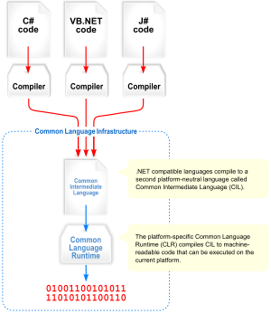
Visual overview of the Common Language Infrastructure (CLI)
Common Language Infrastructure

The core aspects of the .NET framework lie within the Common Language Infrastructure, or CLI. The purpose of the CLI is to provide a language-neutral platform for application development and execution, including functions for exception handling, garbage collection, security, and interoperability. Microsoft's implementation of the CLI is called the Common Language Runtime or CLR.

Assemblies

The intermediate CIL code is housed in .NET assemblies. As mandated by specification, assemblies are stored in the Portable Executable (PE) format, common on the Windows platform for all DLL and EXE files. The assembly consists of one or more files, one of which must contain the manifest, which has the metadata for the assembly. The complete name of an assembly (not to be confused with the filename on disk) contains its simple text name, version number, culture, and public key token. The public key token is a unique hash generated when the assembly is compiled, thus two assemblies with the same public key token are guaranteed to be identical from the point of view of the framework. A private key can also be specified known only to the creator of the assembly and can be used for strong naming and to guarantee that the assembly is from the same author when a new version of the assembly is compiled (required to add an assembly to the Global Assembly Cache).

Metadata

All CLI is self-describing through .NET metadata. The CLR checks the metadata to ensure that the correct method is called. Metadata is usually generated by language compilers but developers can create their own metadata through custom attributes. Metadata contains information about the assembly, and is also used to implement the reflective programming capabilities of .NET Framework.

Security

.NET has its own security mechanism with two general features: Code Access Security (CAS), and validation and verification. Code Access Security is based on evidence that is associated with a specific assembly. Typically the evidence is the source of the assembly (whether it is installed on the local machine or has been downloaded from the intranet or Internet). Code Access Security uses evidence to determine the permissions granted to the code. Other code can demand that calling code is granted a specified permission. The demand causes the CLR to perform a call stack walk: every assembly of each method in the call stack is checked for the required permission; if any assembly is not granted the permission a security exception is thrown.
When an assembly is loaded the CLR performs various tests. Two such tests are validation and verification. During validation the CLR checks that the assembly contains valid metadata and CIL, and whether the internal tables are correct. Verification is not so exact. The verification mechanism checks to see if the code does anything that is 'unsafe'. The algorithm used is quite conservative; hence occasionally code that is 'safe' does not pass. Unsafe code will only be executed if the assembly has the 'skip verification' permission, which generally means code that is installed on the local machine.
.NET Framework uses appdomains as a mechanism for isolating code running in a process. Appdomains can be created and code loaded into or unloaded from them independent of other appdomains. This helps increase the fault tolerance of the application, as faults or crashes in one appdomain do not affect rest of the application. Appdomains can also be configured independently with different security privileges. This can help increase the security of the application by isolating potentially unsafe code. The developer, however, has to split the application into sub domains; it is not done by the CLR.

Class library
Namespaces in the BCL
System
System. CodeDom
System. Collections
System. Diagnostics
System. Globalization
System. IO
System. Resources
System. Text
System.Text.RegularExpressions
Microsoft .NET Framework includes a set of standard class libraries. The class library is organized in a hierarchy of namespaces. Most of the built in APIs are part of either System.* or Microsoft.* namespaces. It encapsulates a large number of common functions, such as file reading and writing, graphic rendering, database interaction, and XML document manipulation, among others. The .NET class libraries are available to all .NET languages. The .NET Framework class library is divided into two parts: the Base Class Library and the Framework Class Library.
The Base Class Library (BCL) includes a small subset of the entire class library and is the core set of classes that serve as the basic API of the Common Language Runtime. The classes in mscorlib.dll and some of the classes in System.dll and System.core.dll are considered to be a part of the BCL. The BCL classes are available in both .NET Framework as well as its alternative implementations including .NET Compact Framework, Microsoft Silver light and Mono.
The Framework Class Library (FCL) is a superset of the BCL classes and refers to the entire class library that ships with .NET Framework. It includes an expanded set of libraries, including Win Forms, ADO.NET, ASP.NET, Language Integrated Query, Windows Presentation Foundation, Windows Communication Foundation among others. The FCL is much larger in scope than standard libraries for languages like C++, and comparable in scope to the standard libraries of Java.
Memory management

The .NET Framework CLR frees the developer from the burden of managing memory (allocating and freeing up when done); instead it does the memory management itself. To this end, the memory allocated to instantiations of .NET types (objects) is done contiguously from the managed heap, a pool of memory managed by the CLR. As long as there exists a reference to an object, which might be either a direct reference to an object or via a graph of objects, the object is considered to be in use by the CLR. When there is no reference to an object, and it cannot be reached or used, it becomes garbage. However, it still holds on to the memory allocated to it. .NET Framework includes a garbage collector which runs periodically, on a separate thread from the application's thread, that enumerates all the unusable objects and reclaims the memory allocated to them.
The .NET Garbage Collector (GC) is a non-deterministic, compacting, mark-and-sweep garbage collector. The GC runs only when a certain amount of memory has been used or there is enough pressure for memory on the system. Since it is not guaranteed when the conditions to reclaim memory are reached, the GC runs are non-deterministic. Each .NET application has a set of roots, which are pointers to objects on the managed heap (managed objects). These include references to static objects and objects defined as local variables or method parameters currently in scope, as well as objects referred to by CPU registers. When the GC runs, it pauses the application, and for each object referred to in the root, it recursively enumerates all the objects reachable from the root objects and marks them as reachable. It uses .NET metadata and reflection to discover the objects encapsulated by an object, and then recursively walk them. It then enumerates all the objects on the heap (which were initially allocated contiguously) using reflection. All objects not marked as reachable are garbage. This is the mark phase. Since the memory held by garbage is not of any consequence, it is considered free space. However, this leaves chunks of free space between objects which were initially contiguous. The objects are then compacted together, by using memory to copy them over to the free space to make them contiguous again. Any reference to an object invalidated by moving the object is updated to reflect the new location by the GC. The application is resumed after the garbage collection is over.
The GC used by .NET Framework is actually generational. Objects are assigned a generation; newly created objects belong to Generation 0. The objects that survive a garbage collection are tagged as Generation 1, and the Generation 1 objects that survive another collection are Generation 2 objects. The .NET Framework uses up to Generation 2 objects. Higher generation objects are garbage collected less frequently than lower generation objects. This helps increase the efficiency of garbage collection, as older objects tend to have a larger lifetime than newer objects. Thus, by removing older (and thus more likely to survive a collection) objects from the scope of a collection run, fewer objects need to be checked and compacted.
Versions: Microsoft started development on the .NET Framework in the late 1990s originally under the name of Next Generation Windows Services (NGWS). By late 2000 the first beta versions of .NET 1.0 were released.
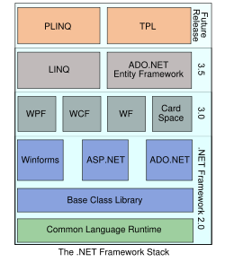
Version | Version Number | Release Date
1.0 | 1.0.3705.0 | 2002-01-05
1.1 | 1.1.4322.573 | 2003-04-01
2.0 | 2.0.50727.42 | 2005-11-07
3.0 | 3.0.4506.30 | 2006-11-06
3.5 | 3.5.21022.8 | 2007-11-09
5.2 ASP.NET

SERVER APPLICATION DEVELOPMENT
Server-side applications in the managed world are implemented through runtime hosts. Unmanaged applications host the common language runtime, which allows your custom managed code to control the behavior of the server. This model provides you with all the features of the common language runtime and class library while gaining the performance and scalability of the host server.
The following illustration shows a basic network schema with managed code running in different server environments. Servers such as IIS and SQL Server can perform standard operations while your application logic executes through the managed code.

SERVER-SIDE MANAGED CODE

ASP.NET is the hosting environment that enables developers to use the .NET Framework to target Web-based applications. However, ASP.NET is more than just a runtime host; it is a complete architecture for developing Web sites and Internet-distributed objects using managed code. Both Web Forms and XML Web services use IIS and ASP.NET as the publishing mechanism for applications, and both have a collection of supporting classes in the .NET Framework.

XML Web services, an important evolution in Web-based technology, are distributed, server-side application components similar to common Web sites. However, unlike Web-based applications, XML Web services components have no UI and are not targeted for browsers such as Internet Explorer and Netscape Navigator. Instead, XML Web services consist of reusable software components designed to be consumed by other applications, such as traditional client applications, Web-based applications, or even other XML Web services. As a result, XML Web services technology is rapidly moving application development and deployment into the highly distributed environment of the Internet.

If you have used earlier versions of ASP technology, you will immediately notice the improvements that ASP.NET and Web Forms offers. For example, you can develop Web Forms pages in any language that supports the .NET Framework. In addition, your code no longer needs to share the same file with your HTTP text (although it can continue to do so if you prefer). Web Forms pages execute in native machine language because, like any other managed application, they take full advantage of the runtime. In contrast, unmanaged ASP pages are always scripted and interpreted. ASP.NET pages are faster, more functional, and easier to develop than unmanaged ASP pages because they interact with the runtime like any managed application.

The .NET Framework also provides a collection of classes and tools to aid in development and consumption of XML Web services applications. XML Web services are built on standards such as SOAP (a remote procedure-call protocol), XML (an extensible data format), and WSDL ( the Web Services Description Language). The .NET Framework is built on these standards to promote interoperability with non-Microsoft solutions.
For example, the Web Services Description Language tool included with the .NET Framework SDK can query an XML Web service published on the Web, parse its WSDL description, and produce C# or Visual Basic source code that your application can use to become a client of the XML Web service. The source code can create classes derived from classes in the class library that handle all the underlying communication using SOAP and XML parsing. Although you can use the class library to consume XML Web services directly, the Web Services Description Language tool and the other tools contained in the SDK facilitate your development efforts with the .NET Framework.
If you develop and publish your own XML Web service, the .NET Framework provides a set of classes that conform to all the underlying communication standards, such as SOAP, WSDL, and XML. Using those classes enables you to focus on the logic of your service, without concerning yourself with the communications infrastructure required by distributed software development.
Finally, like Web Forms pages in the managed environment, your XML Web service will run with the speed of native machine language using the scalable communication of IIS.

ACTIVE SERVER PAGES.NET
ASP.NET is a programming framework built on the common language runtime that can be used on a server to build powerful Web applications. ASP.NET offers several important advantages over previous Web development models:

- Enhanced Performance. ASP.NET is compiled common language runtime code running on the server. Unlike its interpreted predecessors, ASP.NET can take advantage of early binding, just-in-time compilation, native optimization, and caching services right out of the box. This amounts to dramatically better performance before you ever write a line of code.

- World-Class Tool Support. The ASP.NET framework is complemented by a rich toolbox and designer in the Visual Studio integrated development environment. WYSIWYG editing, drag-and-drop server controls, and automatic deployment are just a few of the features this powerful tool provides.

- Power and Flexibility. Because ASP.NET is based on the common language runtime, the power and flexibility of that entire platform is available to Web application developers. The .NET Framework class library, Messaging, and Data Access solutions are all seamlessly accessible from the Web. ASP.NET is also language-independent, so you can choose the language that best applies to your application or partition your application across many languages. Further, common language runtime interoperability guarantees that your existing investment in COM-based development is preserved when migrating to ASP.NET.

- Simplicity. ASP.NET makes it easy to perform common tasks, from simple form submission and client authentication to deployment and site configuration. For example, the ASP.NET page framework allows you to build user interfaces that cleanly separate application logic from presentation code and to handle events in a simple, Visual Basic - like forms processing model. Additionally, the common language runtime simplifies development, with managed code services such as automatic reference counting and garbage collection.

- Manageability. ASP.NET employs a text-based, hierarchical configuration system, which simplifies applying settings to your server environment and Web applications. Because configuration information is stored as plain text, new settings may be applied without the aid of local administration tools. This "zero local administration" philosophy extends to deploying ASP.NET Framework applications as well. An ASP.NET Framework application is deployed to a server simply by copying the necessary files to the server. No server restart is required, even to deploy or replace running compiled code.

- Scalability and Availability. ASP.NET has been designed with scalability in mind, with features specifically tailored to improve performance in clustered and multiprocessor environments. Further, processes are closely monitored and managed by the ASP.NET runtime, so that if one misbehaves (leaks, deadlocks), a new process can be created in its place, which helps keep your application constantly available to handle requests.

- Customizability and Extensibility. ASP.NET delivers a well-factored architecture that allows developers to "plug-in" their code at the appropriate level. In fact, it is possible to extend or replace any subcomponent of the ASP.NET runtime with your own custom-written component. Implementing custom authentication or state services has never been easier.

- Security. With built in Windows authentication and per-application configuration, you can be assured that your applications are secure.

LANGUAGE SUPPORT
The Microsoft .NET Platform currently offers built-in support for three languages: C#, Visual Basic, and Java Script.
WHAT IS ASP.NET WEB FORMS?
The ASP.NET Web Forms page framework is a scalable common language runtime programming model that can be used on the server to dynamically generate Web pages.

Intended as a logical evolution of ASP (ASP.NET provides syntax compatibility with existing pages), the ASP.NET Web Forms framework has been specifically designed to address a number of key deficiencies in the previous model. In particular, it provides:

- The ability to create and use reusable UI controls that can encapsulate common functionality and thus reduce the amount of code that a page developer has to write.
- The ability for developers to cleanly structure their page logic in an orderly fashion (not "spaghetti code").
- The ability for development tools to provide strong WYSIWYG design support for pages (existing ASP code is opaque to tools).

ASP.NET Web Forms pages are text files with an .aspx file name extension. They can be deployed throughout an IIS virtual root directory tree. When a browser client requests .aspx resources, the ASP.NET runtime parses and compiles the target file into a .NET Framework class. This class can then be used to dynamically process incoming requests. (Note that the .aspx file is compiled only the first time it is accessed; the compiled type instance is then reused across multiple requests).

An ASP.NET page can be created simply by taking an existing HTML file and changing its file name extension to .aspx (no modification of code is required). For example, the following sample demonstrates a simple HTML page that collects a user's name and category preference and then performs a form post back to the originating page when a button is clicked:

ASP.NET provides syntax compatibility with existing ASP pages. This includes support for <% %> code render blocks that can be intermixed with HTML content within an .aspx file. These code blocks execute in a top-down manner at page render time.

CODE-BEHIND WEB FORMS

ASP.NET supports two methods of authoring dynamic pages. The first is the method shown in the preceding samples, where the page code is physically declared within the originating .aspx file. An alternative approach--known as the code-behind method--enables the page code to be more cleanly separated from the HTML content into an entirely separate file.

INTRODUCTION TO ASP.NET SERVER CONTROLS

In addition to (or instead of) using <% %> code blocks to program dynamic content, ASP.NET page developers can use ASP.NET server controls to program Web pages. Server controls are declared within an .aspx file using custom tags or intrinsic HTML tags that contain a runat="server" attributes value. Intrinsic HTML tags are handled by one of the controls in the System.Web.UI.HtmlControls namespace. Any tag that doesn't explicitly map to one of the controls is assigned the type of System.Web.UI.HtmlControls.HtmlGenericControl.

Server controls automatically maintain any client-entered values between round trips to the server. This control state is not stored on the server (it is instead stored within an <input type="hidden"> form field that is round-tripped between requests). Note also that no client-side script is required.

In addition to supporting standard HTML input controls, ASP.NET enables developers to utilize richer custom controls on their pages. For example, the following sample demonstrates how the <asp:adrotator> control can be used to dynamically display rotating ads on a page.

- ASP.NET Web Forms provide an easy and powerful way to build dynamic Web UI.
- ASP.NET Web Forms pages can target any browser client (there are no script library or cookie requirements).
- ASP.NET Web Forms pages provide syntax compatibility with existing ASP pages.
- ASP.NET server controls provide an easy way to encapsulate common functionality.
- ASP.NET ships with 45 built-in server controls. Developers can also use controls built by third parties.
- ASP.NET server controls can automatically project both uplevel and downlevel HTML.
- ASP.NET templates provide an easy way to customize the look and feel of list server controls.
- ASP.NET validation controls provide an easy way to do declarative client or server data validation.

5.3 C#.NET

ADO.NET OVERVIEW

ADO.NET is an evolution of the ADO data access model that directly addresses user requirements for developing scalable applications. It was designed specifically for the web with scalability, statelessness, and XML in mind.
ADO.NET uses some ADO objects, such as the Connection and Command objects, and also introduces new objects. Key new ADO.NET objects include the Dataset, Data Reader, and Data Adapter.

The important distinction between this evolved stage of ADO.NET and previous data architectures is that there exists an object -- the DataSet -- that is separate and distinct from any data stores. Because of that, the DataSet functions as a standalone entity. You can think of the DataSet as an always disconnected recordset that knows nothing about the source or destination of the data it contains. Inside a DataSet, much like in a database, there are tables, columns, relationships, constraints, views, and so forth.

A DataAdapter is the object that connects to the database to fill the DataSet. Then, it connects back to the database to update the data there, based on operations performed while the DataSet held the data. In the past, data processing has been primarily connection-based. Now, in an effort to make multi-tiered apps more efficient, data processing is turning to a message-based approach that revolves around chunks of information. At the center of this approach is the DataAdapter, which provides a bridge to retrieve and save data between a DataSet and its source data store. It accomplishes this by means of requests to the appropriate SQL commands made against the data store.

The XML-based DataSet object provides a consistent programming model that works with all models of data storage: flat, relational, and hierarchical. It does this by having no 'knowledge' of the source of its data, and by representing the data that it holds as collections and data types. No matter what the source of the data within the DataSet is, it is manipulated through the same set of standard APIs exposed through the DataSet and its subordinate objects.

While the DataSet has no knowledge of the source of its data, the managed provider has detailed and specific information. The role of the managed provider is to connect, fill, and persist the DataSet to and from data stores. The OLE DB and SQL Server .NET Data Providers (System.Data.OleDb and System.Data.SqlClient) that are part of the .Net Framework provide four basic objects: the Command, Connection, DataReader and DataAdapter. In the remaining sections of this document, we'll walk through each part of the DataSet and the OLE DB/SQL Server .NET Data Providers explaining what they are, and how to program against them.
The following sections will introduce you to some objects that have evolved, and some that are new. These objects are:

- Connections. For connection to and managing transactions against a database.
- Commands. For issuing SQL commands against a database.
- DataReaders. For reading a forward-only stream of data records from a SQL Server data source.
- DataSet. For storing, Remoting and programming against flat data, XML data and relational data.
- DataAdapters. For pushing data into a DataSet, and reconciling data against a database.

When dealing with connections to a database, there are two different options: SQL Server .NET Data Provider (System.Data.SqlClient) and OLE DB .NET Data Provider (System.Data.OleDb). In these samples we will use the SQL Server .NET Data Provider. These are written to talk directly to Microsoft SQL Server. The OLE DB .NET Data Provider is used to talk to any OLE DB provider (as it uses OLE DB underneath).
Connections:
Connections are used to 'talk to' databases, and are represented by provider-specific classes such as SqlConnection. Commands travel over connections and resultsets are returned in the form of streams which can be read by a DataReader object, or pushed into a DataSet object.

Commands:
Commands contain the information that is submitted to a database, and are represented by provider-specific classes such as SqlCommand. A command can be a stored procedure call, an UPDATE statement, or a statement that returns results. You can also use input and output parameters, and return values as part of your command syntax. The example below shows how to issue an INSERT statement against the Northwind database.

DataReaders:
The DataReader object is somewhat synonymous with a read-only/forward-only cursor over data. The DataReader API supports flat as well as hierarchical data. A DataReader object is returned after executing a command against a database. The format of the returned DataReader object is different from a recordset. For example, you might use the DataReader to show the results of a search list in a web page.

DATASETS AND DATAADAPTERS:
DataSets
The DataSet object is similar to the ADO Recordset object, but more powerful, and with one other important distinction: the DataSet is always disconnected. The DataSet object represents a cache of data, with database-like structures such as tables, columns, relationships, and constraints. However, though a DataSet can and does behave much like a database, it is important to remember that DataSet objects do not interact directly with databases, or other source data. This allows the developer to work with a programming model that is always consistent, regardless of where the source data resides. Data coming from a database, an XML file, from code, or user input can all be placed into DataSet objects. Then, as changes are made to the DataSet they can be tracked and verified before updating the source data. The GetChanges method of the DataSet object actually creates a second DatSet that contains only the changes to the data. This DataSet is then used by a DataAdapter (or other objects) to update the original data source.
The DataSet has many XML characteristics, including the ability to produce and consume XML data and XML schemas. XML schemas can be used to describe schemas interchanged via WebServices. In fact, a DataSet with a schema can actually be compiled for type safety and statement completion.

DATAADAPTERS (OLEDB/SQL)

The DataAdapter object works as a bridge between the DataSet and the source data. Using the provider-specific SqlDataAdapter (along with its associated SqlCommand and SqlConnection) can increase overall performance when working with a Microsoft SQL Server databases. For other OLE DB-supported databases, you would use the OleDbDataAdapter object and its associated OleDbCommand and OleDbConnection objects.
The DataAdapter object uses commands to update the data source after changes have been made to the DataSet. Using the Fill method of the DataAdapter calls the SELECT command; using the Update method calls the INSERT, UPDATE or DELETE command for each changed row. You can explicitly set these commands in order to control the statements used at runtime to resolve changes, including the use of stored procedures. For ad-hoc scenarios, a CommandBuilder object can generate these at run-time based upon a select statement. However, this run-time generation requires an extra round-trip to the server in order to gather required metadata, so explicitly providing the INSERT, UPDATE, and DELETE commands at design time will result in better run-time performance.
- ADO.NET is the next evolution of ADO for the .Net Framework.
- ADO.NET was created with n-Tier, statelessness and XML in the forefront. Two new objects, the DataSet and DataAdapter, are provided for these scenarios.
- ADO.NET can be used to get data from a stream, or to store data in a cache for updates.
- There is a lot more information about ADO.NET in the documentation.
- Remember, you can execute a command directly against the database in order to do inserts, updates, and deletes. You don't need to first put data into a DataSet in order to insert, update, or delete it.
Also, you can use a DataSet to bind to the data, move through the data, and navigate data relationships
5.4 SQL SERVER -2005
A database management, or DBMS, gives the user access to their data and helps them transform the data into information. Such database management systems include dBase, paradox, IMS, SQL Server and SQL Server. These systems allow users to create, update and extract information from their database.
A database is a structured collection of data. Data refers to the characteristics of people, things and events. SQL Server stores each data item in its own fields. In SQL Server, the fields relating to a particular person, thing or event are bundled together to form a single complete unit of data, called a record (it can also be referred to as raw or an occurrence). Each record is made up of a number of fields. No two fields in a record can have the same field name.
During an SQL Server Database design project, the analysis of your business needs identifies all the fields or attributes of interest. If your business needs change over time, you define any additional fields or change the definition of existing fields.
SQL SERVER TABLES
SQL Server stores records relating to each other in a table. Different tables are created for the various groups of information. Related tables are grouped together to form a database.
PRIMARY KEY
Every table in SQL Server has a field or a combination of fields that uniquely identifies each record in the table. The Unique identifier is called the Primary Key, or simply the Key. The primary key provides the means to distinguish one record from all other in a table. It allows the user and the database system to identify, locate and refer to one particular record in the database.
RELATIONAL DATABASE
Sometimes all the information of interest to a business operation can be stored in one table. SQL Server makes it very easy to link the data in multiple tables. Matching an employee to the department in which they work is one example. This is what makes SQL Server a relational database management system, or RDBMS. It stores data in two or more tables and enables you to define relationships between the table and enables you to define relationships between the tables.
FOREIGN KEY
When a field is one table matches the primary key of another field is referred to as a foreign key. A foreign key is a field or a group of fields in one table whose values match those of the primary key of another table.
REFERENTIAL INTEGRITY
Not only does SQL Server allow you to link multiple tables, it also maintains consistency between them. Ensuring that the data among related tables is correctly matched is referred to as maintaining referential integrity.
DATA ABSTRACTION A major purpose of a database system is to provide users with an abstract view of the data. This system hides certain details of how the data is stored and maintained. Data abstraction is divided into three levels.
Physical level: This is the lowest level of abstraction at which one describes how the data are actually stored.
Conceptual Level: At this level of database abstraction all the attributed and what data are actually stored is described and entries and relationship among them.
View level: This is the highest level of abstraction at which one describes only part of the database.
ADVANTAGES OF RDBMS
- Redundancy can be avoided
- Inconsistency can be eliminated
- Data can be Shared
- Standards can be enforced
- Security restrictions ca be applied
- Integrity can be maintained
- Conflicting requirements can be balanced
- Data independence can be achieved.

DISADVANTAGES OF DBMS
A significant disadvantage of the DBMS system is cost. In addition to the cost of purchasing of developing the software, the hardware has to be upgraded to allow for the extensive programs and the workspace required for their execution and storage. While centralization reduces duplication, the lack of duplication requires that the database be adequately backed up so that in case of failure the data can be recovered.
FEATURES OF SQL SERVER (RDBMS)
SQL SERVER is one of the leading database management systems (DBMS) because it is the only Database that meets the uncompromising requirements of today’s most demanding information systems. From complex decision support systems (DSS) to the most rigorous online transaction processing (OLTP) application, even application that require simultaneous DSS and OLTP access to the same critical data, SQL Server leads the industry in both performance and capability.
SQL SERVER is a truly portable, distributed, and open DBMS that delivers unmatched performance, continuous operation and support for every database.
SQL SERVER RDBMS is high performance fault tolerant DBMS which is specially designed for online transactions processing and for handling large database application.
SQL SERVER with transactions processing option offers two features which contribute to very high level of transaction processing throughput, which are
- The row level lock manager
ENTERPRISE WIDE DATA SHARING
The unrivaled portability and connectivity of the SQL SERVER DBMS enables all the systems in the organization to be linked into a singular, integrated computing resource.
PORTABILITY
SQL SERVER is fully portable to more than 80 distinct hardware and operating systems platforms, including UNIX, MSDOS, OS/2, Macintosh and dozens of proprietary platforms. This portability gives complete freedom to choose the database server platform that meets the system requirements.
OPEN SYSTEMS
SQL SERVER offers a leading implementation of industry –standard SQL. SQL Server’s open architecture integrates SQL SERVER and non –SQL SERVER DBMS with industry’s most comprehensive collection of tools, application, and third party software products SQL Server’s Open architecture provides transparent access to data from other relational database and even non-relational database.
DISTRIBUTED DATA SHARING
SQL Server’s networking and distributed database capabilities to access data stored on remote server with the same ease as if the information was stored on a single local computer. A single SQL statement can access data at multiple sites. You can store data where system requirements such as performance, security or availability dictate.

UNMATCHED PERFORMANCE
The most advanced architecture in the industry allows the SQL SERVER DBMS to deliver unmatched performance.
SOPHISTICATED CONCURRENCY CONTROL
Real World applications demand access to critical data. With most database Systems application becomes “contention bound” – which performance is limited not by the CPU power or by disk I/O, but user waiting on one another for data access. SQL Server employs full, unrestricted row-level locking and contention free queries to minimize and in many cases entirely eliminates contention wait times.
NO I/O BOTTLENECKS
SQL Server’s fast commit groups commit and deferred write technologies dramatically reduce disk I/O bottlenecks. While some database write whole data block to disk at commit time, SQL Server commits transactions with at most sequential log file on disk at commit time, On high throughput systems, one sequential writes typically group commit multiple transactions. Data read by the transaction remains as shared memory so that other transactions may access that data without reading it again from disk. Since fast commits write all data necessary to the recovery to the log file, modified blocks are written back to the database independently of the transaction commit, when written from memory to disk.

SYSTEM DESIGN

6.1. INTRODUCTION

Software design sits at the technical kernel of the software engineering process and is applied regardless of the development paradigm and area of application. Design is the first step in the development phase for any engineered product or system. The designer’s goal is to produce a model or representation of an entity that will later be built. Beginning, once system requirement have been specified and analyzed, system design is the first of the three technical activities -design, code and test that is required to build and verify software.
The importance can be stated with a single word “Quality”. Design is the place where quality is fostered in software development. Design provides us with representations of software that can assess for quality. Design is the only way that we can accurately translate a employee’s view into a finished software product or system. Software design serves as a foundation for all the software engineering steps that follow. Without a strong design we risk building an unstable system – one that will be difficult to test, one whose quality cannot be assessed until the last stage.
During design, progressive refinement of data structure, program structure, and procedural details are developed reviewed and documented. System design can be viewed from either technical or project management perspective. From the technical point of view, design is comprised of four activities – architectural design, data structure design, interface design and procedural design.
6.2 NORMALIZATION
It is a process of converting a relation to a standard form. The process is used to handle the problems that can arise due to data redundancy i.e. repetition of data in the database, maintain data integrity as well as handling problems that can arise due to insertion, updating, deletion anomalies.
Decomposing is the process of splitting relations into multiple relations to eliminate anomalies and maintain anomalies and maintain data integrity. To do this we use normal forms or rules for structuring relation.
Insertion anomaly: Inability to add data to the database due to absence of other data.
Deletion anomaly: Unintended loss of data due to deletion of other data.
Update anomaly: Data inconsistency resulting from data redundancy and partial update
Normal Forms: These are the rules for structuring relations that eliminate anomalies.
FIRST NORMAL FORM:
A relation is said to be in first normal form if the values in the relation are atomic for every attribute in the relation. By this we mean simply that no attribute value can be a set of values or, as it is sometimes expressed, a repeating group.
SECOND NORMAL FORM:
A relation is said to be in second Normal form is it is in first normal form and it should satisfy any one of the following rules.
- Primary key is a not a composite primary key
- No non key attributes are present
- Every non key attribute is fully functionally dependent on full set of primary key.
THIRD NORMAL FORM:
A relation is said to be in third normal form if their exits no transitive dependencies.
Transitive Dependency: If two non key attributes depend on each other as well as on the primary key then they are said to be transitively dependent.
The above normalization principles were applied to decompose the data in multiple tables thereby making the data to be maintained in a consistent state.
6.3 E-R Diagrams
  - The relation upon the system is structure through a conceptual ER-Diagram, which not only specifics the existential entities but also the standard relations through which the system exists and the cardinalities that are necessary for the system state to continue.
  - The entity Relationship Diagram (ERD) depicts the relationship between the data objects. The ERD is the notation that is used to conduct the date modeling activity the attributes of each data object noted is the ERD can be described resign a data object descriptions.
  - The set of primary components that are identified by the ERD are
  - Data object
  - Relationships
  - Attributes
  - Various types of indicators.
The primary purpose of the ERD is to represent data objects and their relationships.

ER Diagram:

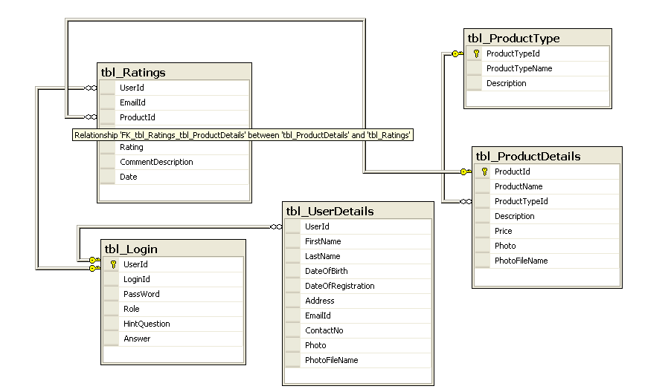
6.4 DATA FLOW DIAGRAMS
A data flow diagram is graphical tool used to describe and analyze movement of data through a system. These are the central tool and the basis from which the other components are developed. The transformation of data from input to output, through processed, may be described logically and independently of physical components associated with the system. These are known as the logical data flow diagrams. The physical data flow diagrams show the actual implements and movement of data between people, departments and workstations. A full description of a system actually consists of a set of data flow diagrams. Using two familiar notations Yourdon, Gane and Sarson notation develops the data flow diagrams. Each component in a DFD is labeled with a descriptive name. Process is further identified with a number that will be used for identification purpose. The development of DFD’S is done in several levels. Each process in lower level diagrams can be broken down into a more detailed DFD in the next level. The lop-level diagram is often called context diagram. It consists a single process bit, which plays vital role in studying the current system. The process in the context level diagram is exploded into other process at the first level DFD.
The idea behind the explosion of a process into more process is that understanding at one level of detail is exploded into greater detail at the next level. This is done until further explosion is necessary and an adequate amount of detail is described for analyst to understand the process.
Larry Constantine first developed the DFD as a way of expressing system requirements in a graphical from, this lead to the modular design.
A DFD is also known as a “bubble Chart” has the purpose of clarifying system requirements and identifying major transformations that will become programs in system design. So it is the starting point of the design to the lowest level of detail. A DFD consists of a series of bubbles joined by data flows in the system.
DFD SYMBOLS:
In the DFD, there are four symbols
- A square defines a source(originator) or destination of system data
- An arrow identifies data flow. It is the pipeline through which the information flows
- A circle or a bubble represents a process that transforms incoming data flow into outgoing data flows.
- An open rectangle is a data store, data at rest or a temporary repository of data

Process that transforms data flow.

Source or Destination of data
Data flow

Data Store

CONSTRUCTING A DFD:
Several rules of thumb are used in drawing DFD’S:
- Process should be named and numbered for an easy reference. Each name should be representative of the process.
- The direction of flow is from top to bottom and from left to right. Data traditionally flow from source to the destination although they may flow back to the source. One way to indicate this is to draw long flow line back to a source. An alternative way is to repeat the source symbol as a destination. Since it is used more than once in the DFD it is marked with a short diagonal.
- When a process is exploded into lower level details, they are numbered.
- The names of data stores and destinations are written in capital letters. Process and dataflow names have the first letter of each work capitalized.
A DFD typically shows the minimum contents of data store. Each data store should contain all the data elements that flow in and out.
Questionnaires should contain all the data elements that flow in and out. Missing interfaces redundancies and like is then accounted for often through interviews.

SAILENT FEATURES OF DFD’S
- The DFD shows flow of data, not of control loops and decision are controlled considerations do not appear on a DFD.
- The DFD does not indicate the time factor involved in any process whether the dataflow take place daily, weekly, monthly or yearly.
- The sequence of events is not brought out on the DFD.

TYPES OF DATA FLOW DIAGRAMS
- Current Physical
- Current Logical
- New Logical
- New Physical

CURRENT PHYSICAL:
In Current Physical DFD process label include the name of people or their positions or the names of computer systems that might provide some of the overall system-processing label includes an identification of the technology used to process the data. Similarly data flows and data stores are often labels with the names of the actual physical media on which data are stored such as file folders, computer files, business forms or computer tapes.
CURRENT LOGICAL:
The physical aspects at the system are removed as much as possible so that the current system is reduced to its essence to the data and the processors that transforms them regardless of actual physical form.
NEW LOGICAL:
This is exactly like a current logical model if the user were completely happy with the user were completely happy with the functionality of the current system but had problems with how it was implemented typically through the new logical model will differ from current logical model while having additional functions, absolute function removal and inefficient flows recognized.
NEW PHYSICAL:
The new physical represents only the physical implementation of the new system.

RULES GOVERNING THE DFD’S

PROCESS
- No process can have only outputs.
- No process can have only inputs. If an object has only inputs than it must be a sink.
- A process has a verb phrase label.
DATA STORE
- Data cannot move directly from one data store to another data store, a process must move data.
- Data cannot move directly from an outside source to a data store, a process, which receives, must move data from the source and place the data into data store
- A data store has a noun phrase label.
SOURCE OR SINK
The origin and /or destination of data.
- Data cannot move direly from a source to sink it must be moved by a process
- A source and /or sink has a noun phrase land

DATA FLOW
- A Data Flow has only one direction of flow between symbols. It may flow in both directions between a process and a data store to show a read before an update. The later is usually indicated however by two separate arrows since these happen at different type.
- A join in DFD means that exactly the same data comes from any of two or more different processes data store or sink to a common location.
- A data flow cannot go directly back to the same process it leads. There must be at least one other process that handles the data flow produce some other data flow returns the original data into the beginning process.
- A Data flow to a data store means update (delete or change).
- A data Flow from a data store means retrieve or use.
A data flow has a noun phrase label more than one data flow noun phrase can appear on a single arrow as long as all of the flows on the same arrow move together as one package.

Data Flow Diagrams
DFD Diagrams:
Context Level (0th level DFD)
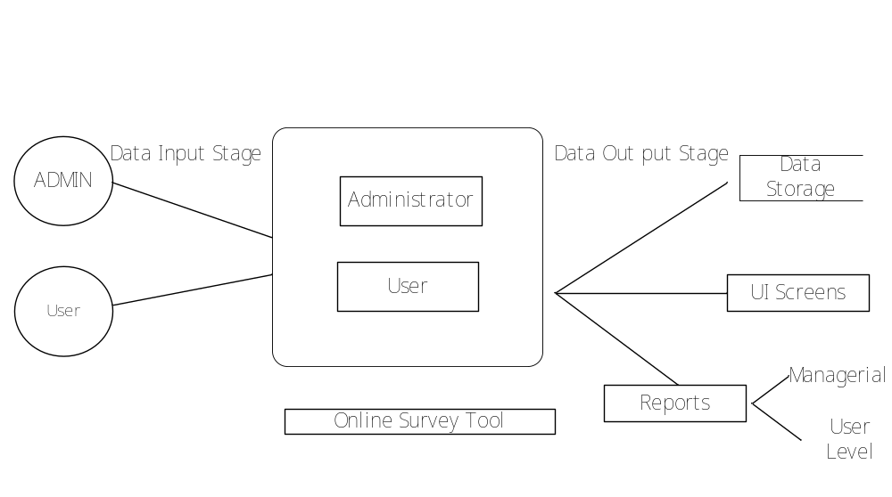

Login DFD
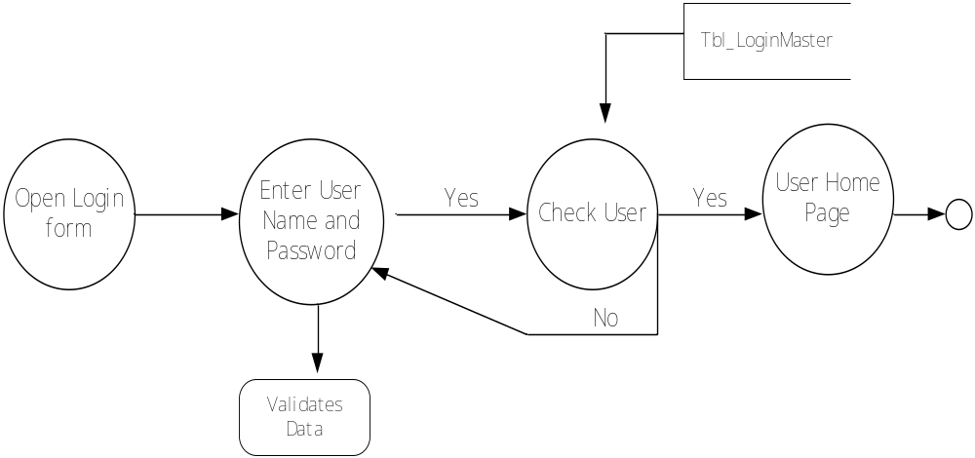
Admin Functionalities
1st Level
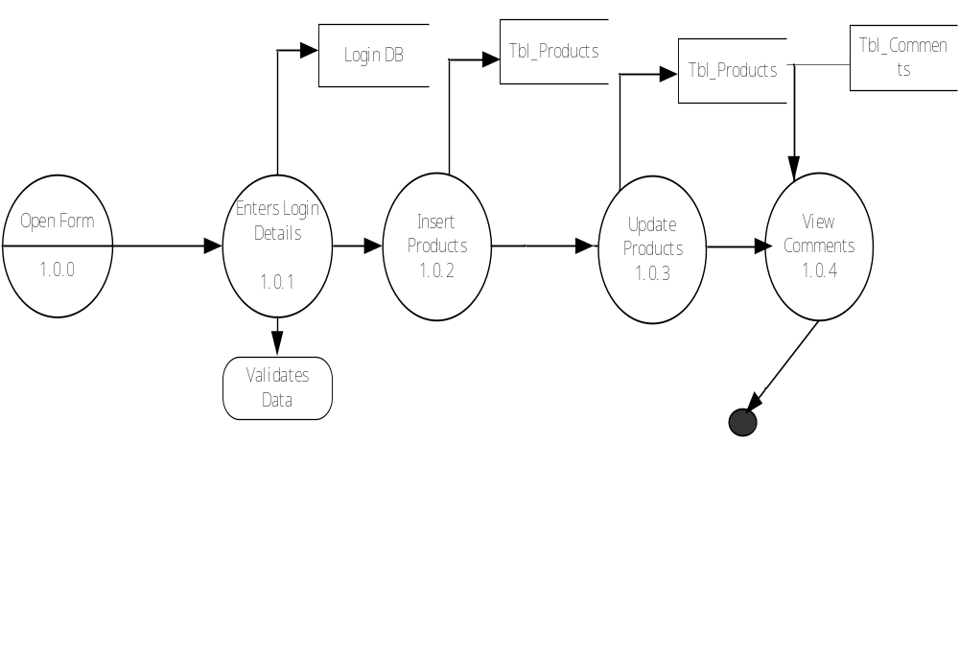

Admin Functionalities
2nd Level
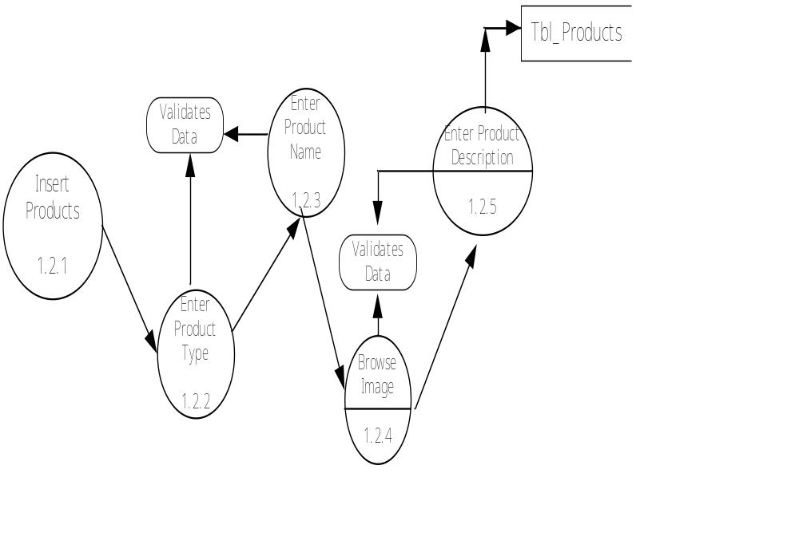

User Functionalities
1st Level

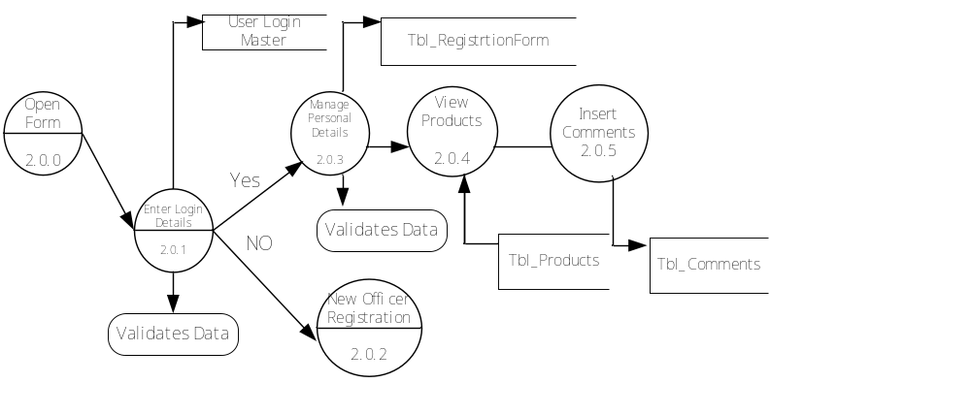

User Functionalities
2nd Level
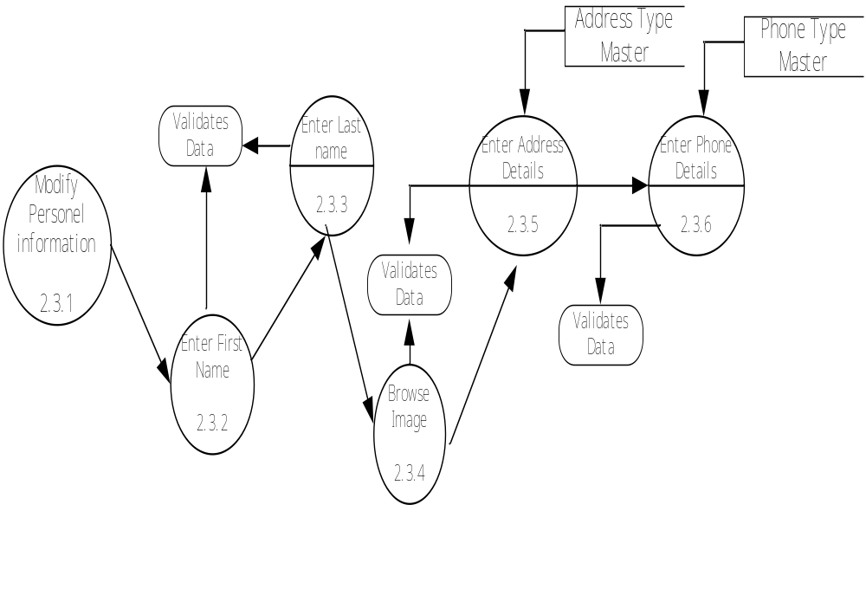

6.5 DATA DICTIONARY
After carefully understanding the requirements of the client the entire data storage requirements are divided into tables. The below tables are normalized to avoid any anomalies during the course of data entry.
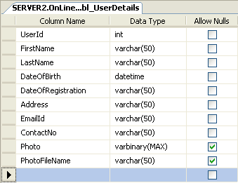

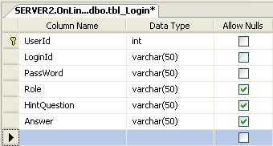

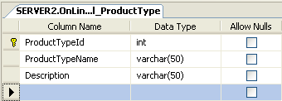

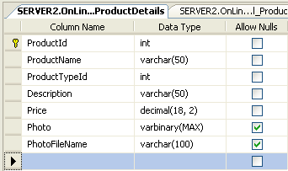

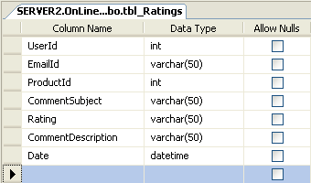

  - UML DIAGRAMS
The use case diagrams describe system functionality as a set of tasks that the system must carry out and actors who interact with the system to complete the tasks.

Use Case:

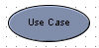 | Each use case on the diagram represents a single task that the system needs to carry out. Buy a Product, Add Client, Make Purchase and Validate Order Information are all examples of use cases. Some use cases may include or extend a task represented by another use case. For example, in order to make a purchase, the order information will need to be validated.

Actor
 | An actor is anything outside the system that interacts with the system to complete a task. It could be a user or another system. The actor "uses" the use case to complete a task. System Administrator, Credit Authentication System, Accounting System and Web Client are all examples of actors. Often, it is useful to look at the set of use cases that an actor has access to -- this defines the actor's overall role in the system.

Association:
The association is the link that is drawn between and actor and a use case. It indicates which actors interact with the system to complete the various tasks.

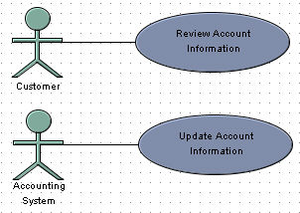

Includes:
Use the includes link to show that one use case includes the task described by another use case. For example, saving a Visual Case project includes saving the diagrams and saving the project settings. Sometimes the word "Uses" is used instead of "Includes"
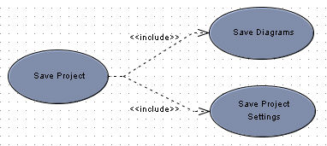

Generalization:
The generalization link is an informal way of showing that one use case is similar to another use case, but with a little bit of extra functionality. One use case inherits the functionality represented by another use case and adds some additional behavior to it.

Extends:
The extends link is used to show that one use case extends the task described by another use case. It's very similar to generalization, but is much more formalized.
The use case that is extended is always referred to as the base use case and has one or more defined extension points. The extension points show exactly where extending use cases are allowed to add functionality. The extending use case doesn't have to add functionality at all of the base use case's extension points. The extension link indicates which extension points are being used.
UML Diagrams: Use Cases
System
Admin
User
Registration
Manage Products
Reports
Search Products
Manage Profile
Comments
Login
Logout

Sequence Diagrams
Admin Login Sequence
: Admin
Login
clsLogin
DALSQLHelper
Database
1 : Req For Login Page()
2 : Login()
3 Execute NonQuery()
4 : Execute stored procedure()
5 : Response For Execute NonQuery()
6 : Get Response()
7 : Show Result()

Administrator Insert Product Details
Products
clsProducts
DALSQLHelper
Database
: Admin
1 : Req For Product Page()
2 : Insert Product Details()
3 : Execute NonQuery
4 : Execute stored procedure
5 : Response For Execute NonQuery()
6 : Get Response()
7 : Show Result()
Admin Sequence to Search Products
Admin
frmProducts
BAL:clsProducts
DAL:clsSqlHelper

DataBase
1 : Enter Products
2 : GetProducts()
3 : ExecuteDataset()
4 : ExecuteStoredProcedure()

5 : Response()
6 : Show Result()
Admin Sequence to View Comments
Admin
frmcomments
BAL:clsComments
DAL:clsSqlHelper

DataBase
1 : Enter Products
2 : GetComments()
3 : ExecuteDataset()
4 : ExecuteStoredProcedure()

5 : Response()
6 : Show Result()

Admin Sequence Reports
Admin
frmReports
BAL:clsReports
DAL:clsSqlHelper

DataBase
1 : Enter Products
2 : GetReports()
3 : ExecuteDataset()
4 : ExecuteStoredProcedure()

5 : Response()
6 : Show Result()

User Login
Login
clsLogin
DALSQLHelper
Database
: User
1 : Req For Login Page()
2 : Login()
3 : check UserLogin()
4 : Execute NonQuery()
5 : Response For Execute NonQuery()
6 : Get Response()
7 : Show Result()

User Registration Sequence
User
frmRegistration
BL:cls_User
DAL:cls_SqlHelper
Database
1 : Get Registration Form
2 : insertUserData ()
3 : ExecuteNonQuery ()
4 : ExecuteStoredProcedure()
6 : Response()
7 : Response for InsertUserData()

User Sequence to Search Products
User
frmProducts
BAL:clsProducts
DAL:clsSqlHelper

DataBase
1 : Enter Products
2 : GetProducts()
3 : ExecuteDataset()
4 : ExecuteStoredProcedure()

5 : Response()
6 : Show Result()

User Insert Comment Details
frmComment
clsProducts
DALSQLHelper
Database
: Admin
1 : Req For Comment Page()
2 : Execute StordProcedure
3 : Insert Comment

4 : Execute NonQuery()
5 : Response For Execute NonQuery()
6 : Get Response()
7 : Show Result()

Activity Diagrams
Login Activity
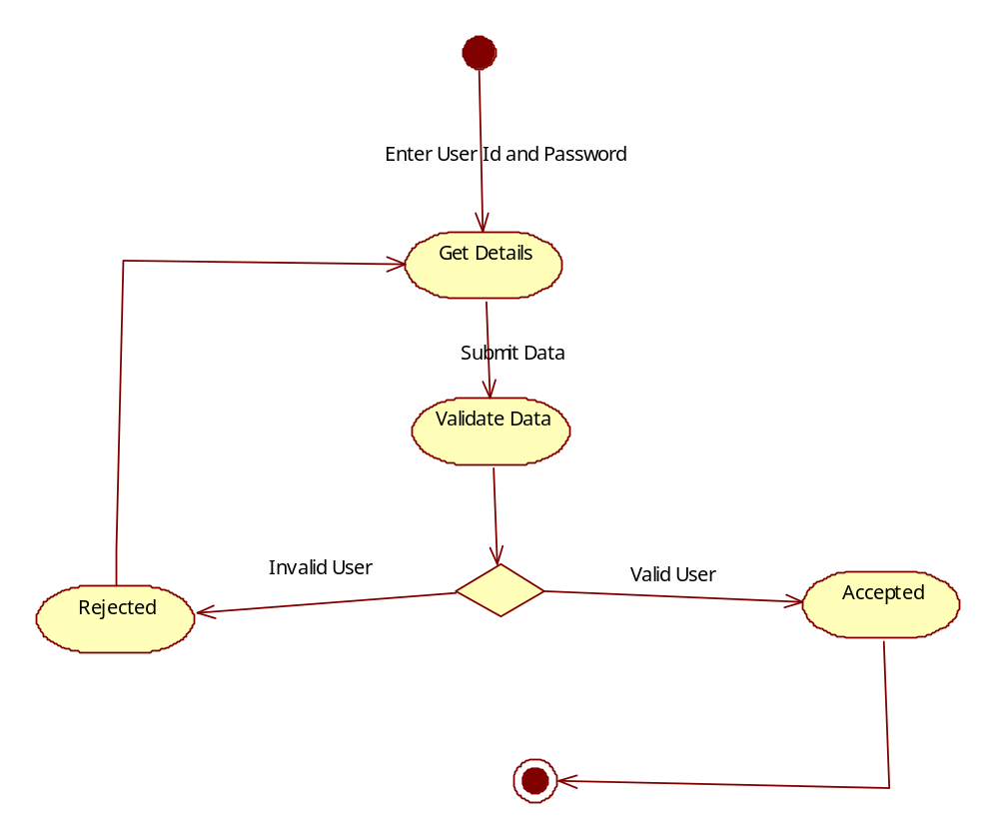

Administrator Activities
Home Page
Administrator
Login Form
Enter UserId/Password
Valid User Id/Pwd
Invalid User Id/Pwd
Search Products
Login
Vew Comments
Manage products
Logout
View Repots
User Activities
Home Page
Citizen
Login Form
Enter UserId/Password
Valid User Id/Pwd
Invalid User Id/Pwd
View Profile
Login
Registration
Change Pwd

Search Products
Logout
Insert Comment

Collaboration Diagrams
Admin Login
Login
clsLogin
DALSQLHelper
Database
: Admin
1 : Req For Login Page()
2 : Login()
3 : check UserLogin()
4 : Execute NonQuery()
5 : Response For Execute NonQuery()
6 : Get Response()
7 : Show Result()

Admin Insert Products:
Product
clsProduct
DALSQLHelper
Database
: Admin
1 : Req For Product Page()
2 : InsertProduct()
3 : ExecuteNonuery()
4 : Execute StoredProcedure()
5 : Response For Execute NonQuery()
6 : Get Response()
7 : Show Result()

Admin Search Products:
Product
clsProduct
DALSQLHelper
Database
: Admin
1 : Req For Product Page()
2 : GetProduct()
3 : ExecuteDataset()
4 : Execute StoredProcedure()
5 : Response For ExecuteDataset ()
6 : Get Response()
7 : Show Result()

Admin View Comments:
Comments
clsComments
DALSQLHelper
Database
: Admin
1 : Req For Comment Page()
2 : GetCommets()
3 : ExecuteDataset()
4 : Execute StoredProcedure()
5 : Response For ExecuteDataset ()
6 : Get Response()
7 : Show Result()

Admin Reports:

Reports
clsReports
DALSQLHelper
Database
: Admin
1 : Req For Report Page()
2 : GetReports ()
3 : ExecuteDataset()
4 : Execute StoredProcedure()
5 : Response For ExecuteDataset ()
6 : Get Response()
7 : Show Result()

User Login
Login
clsLogin
DALSQLHelper
Database
: User
1 : Req For Login Page()
2 : Login()
3 : check UserLogin()
4 : Execute NonQuery()
5 : Response For Execute NonQuery()
6 : Get Response()
7 : Show Result()

User Registration:
Registration
clsUser
DALSQLHelper
Database
: User
1 : Req For User Registration Page()
2 : InsertRegistration()
3 : ExecuteNonuery()
4 : Execute StoredProcedure()
5 : Response For Execute NonQuery()
6 : Get Response()
7 : Show Result()

User Search Products:
Product
clsProduct
DALSQLHelper
Database
: User
1 : Req For Product Page()
2 : GetProduct()
3 : ExecuteDataset()
4 : Execute StoredProcedure()
5 : Response For ExecuteDataset ()
6 : Get Response()
7 : Show Result()

User Insert Comments:
Comments
clsComment
DALSQLHelper
Database
: User
1 : Req For User Comment Page()
2 : InsertComment()
3 : ExecuteNonuery()
4 : Execute StoredProcedure()
5 : Response For Execute NonQuery()
6 : Get Response()
7 : Show Result()

Class Diagram
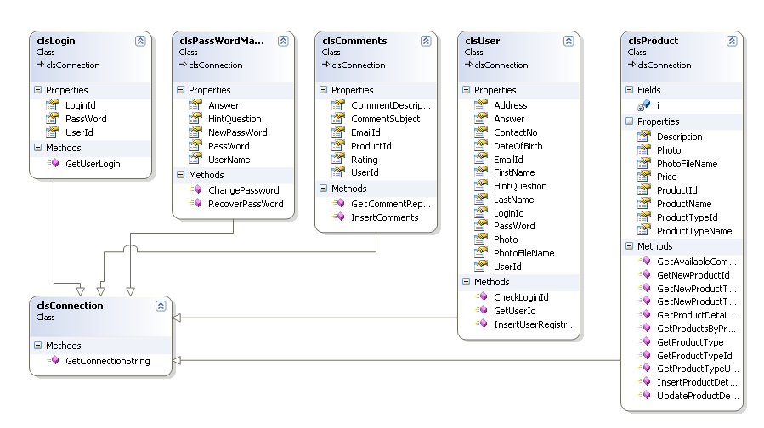

Deployment Diagram

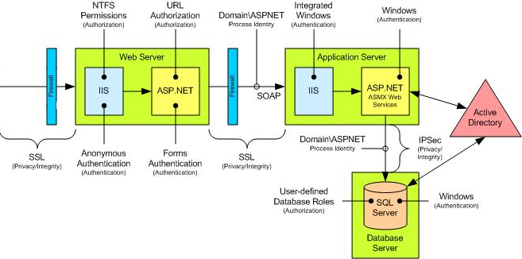
OUTPUT SCREENS
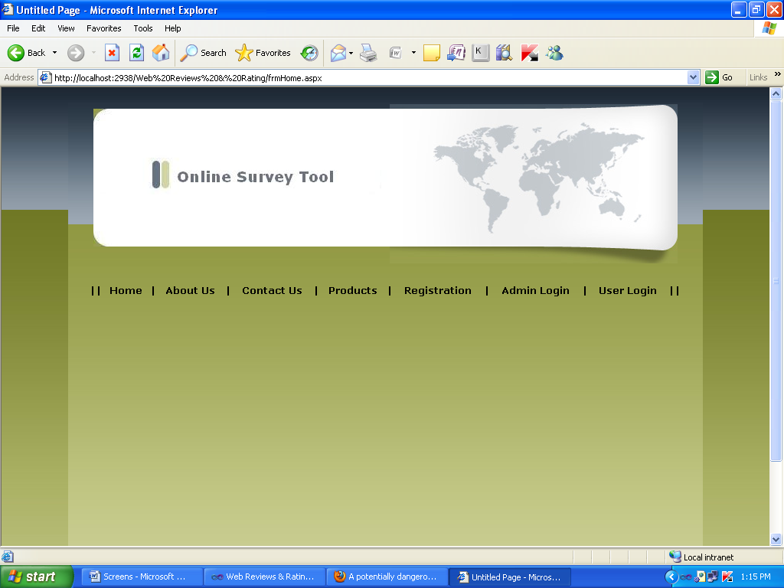

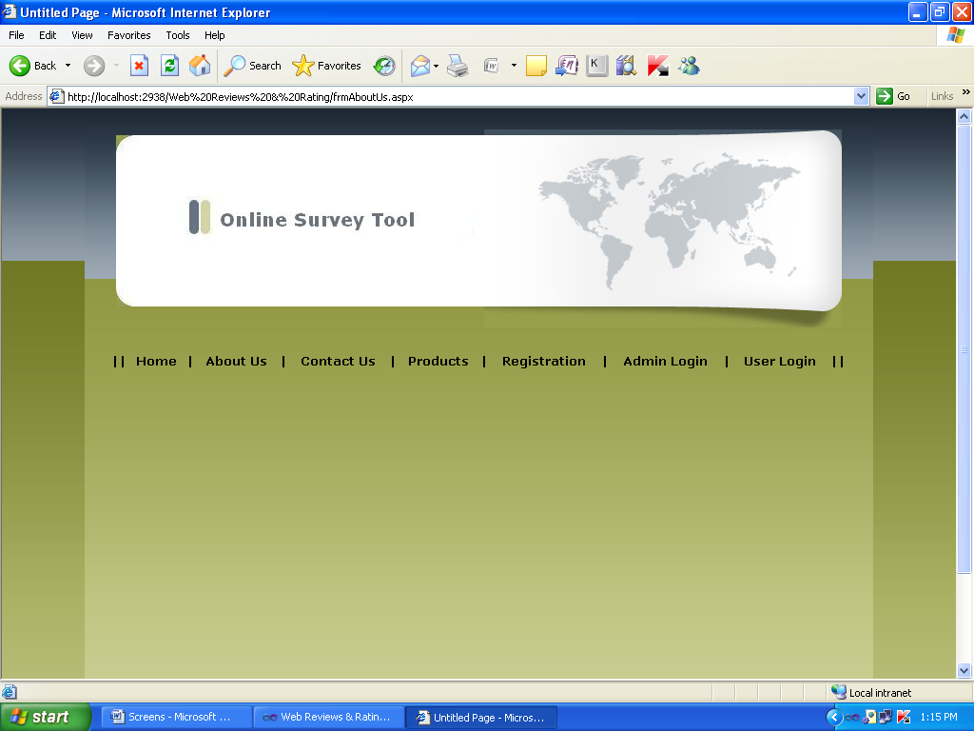

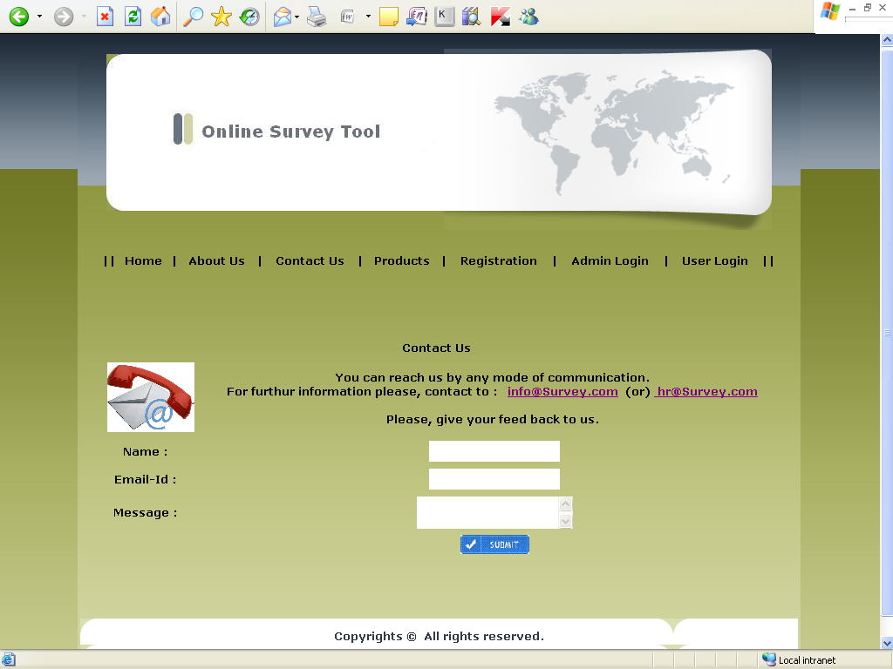

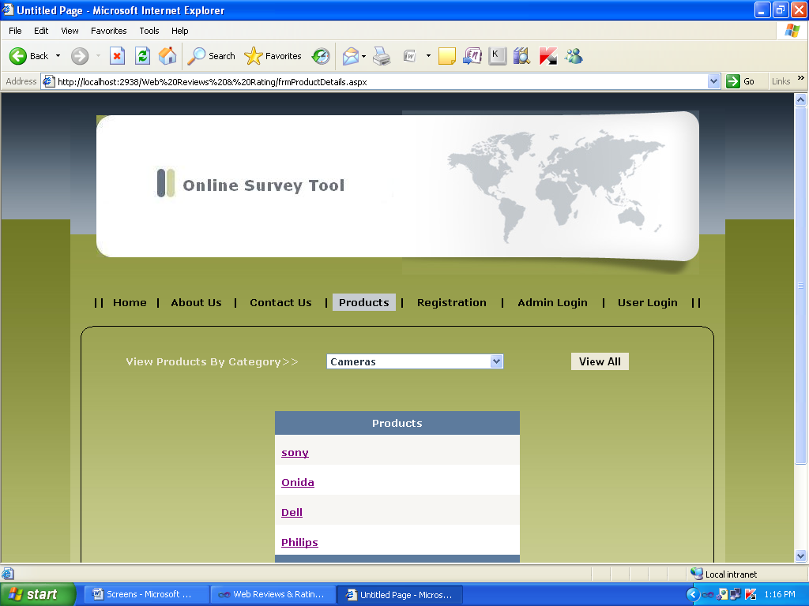

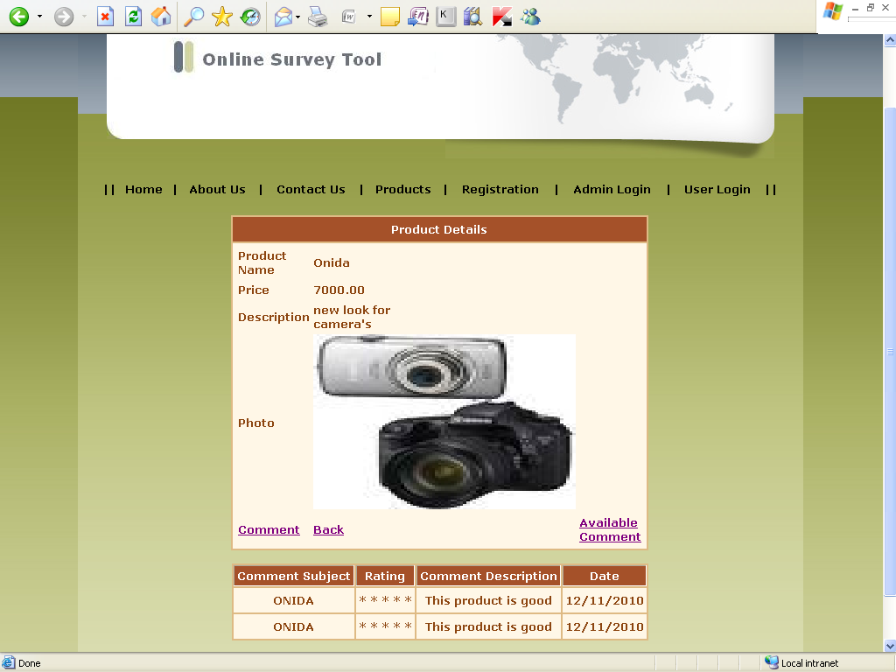

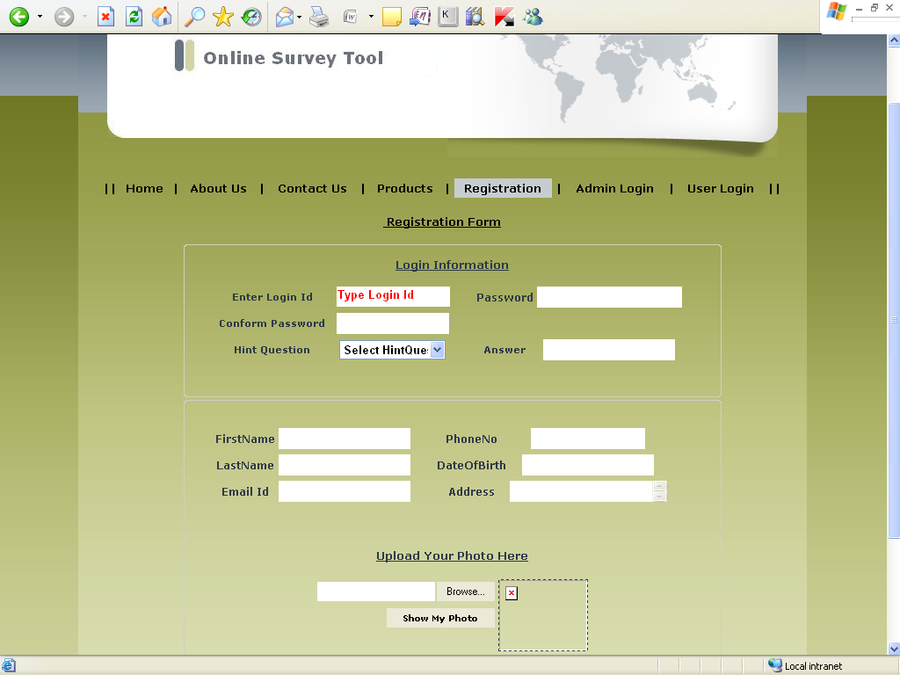

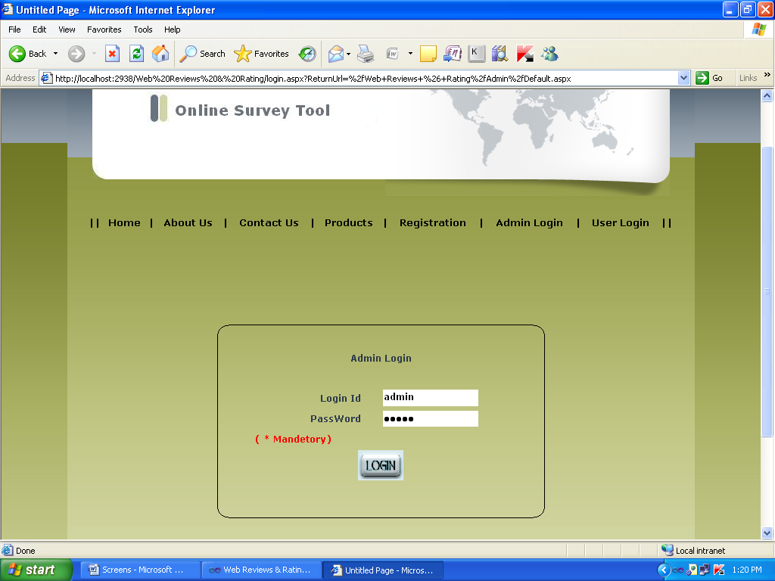

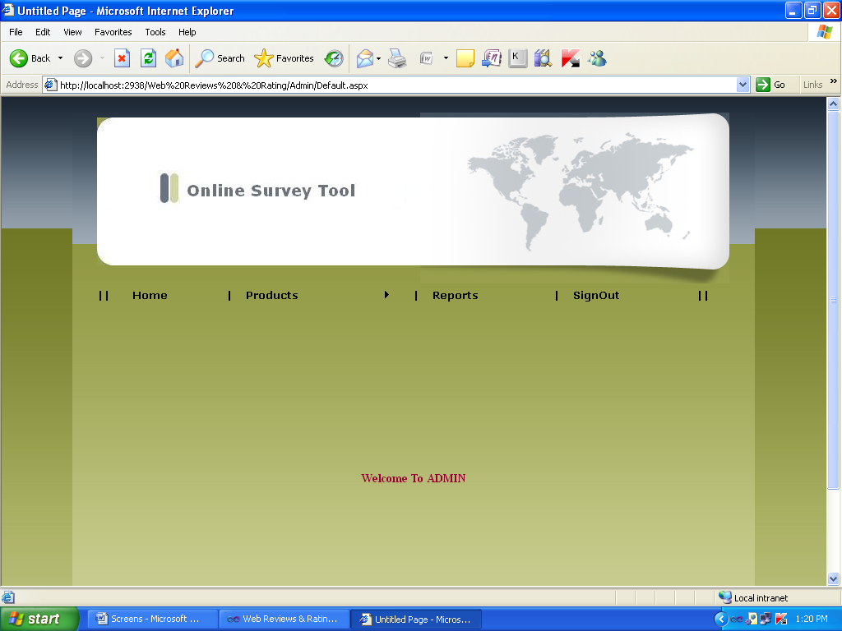
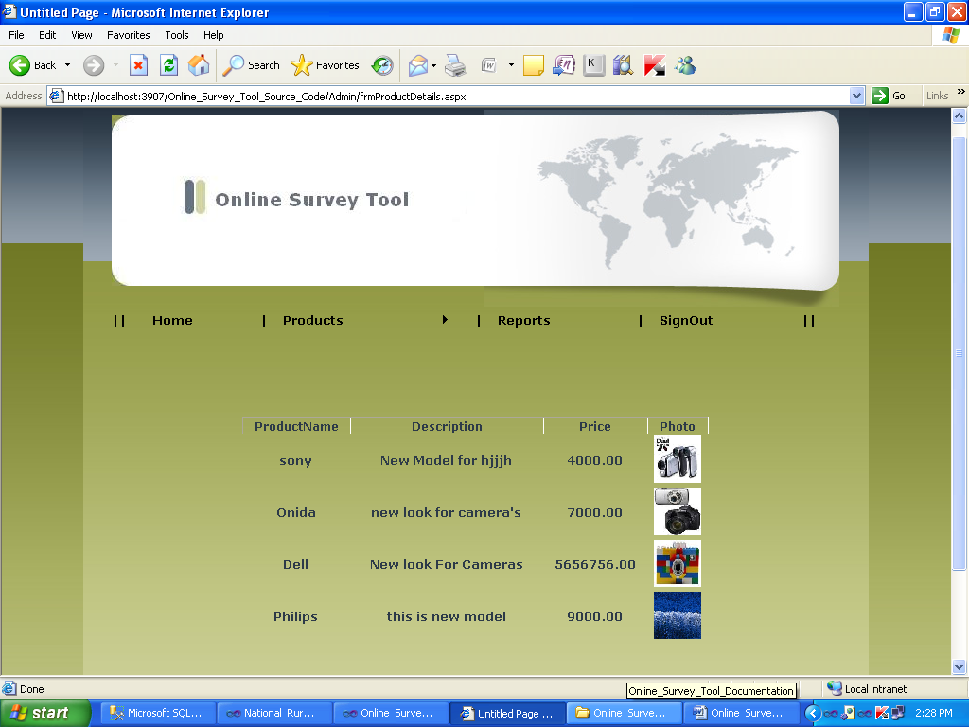

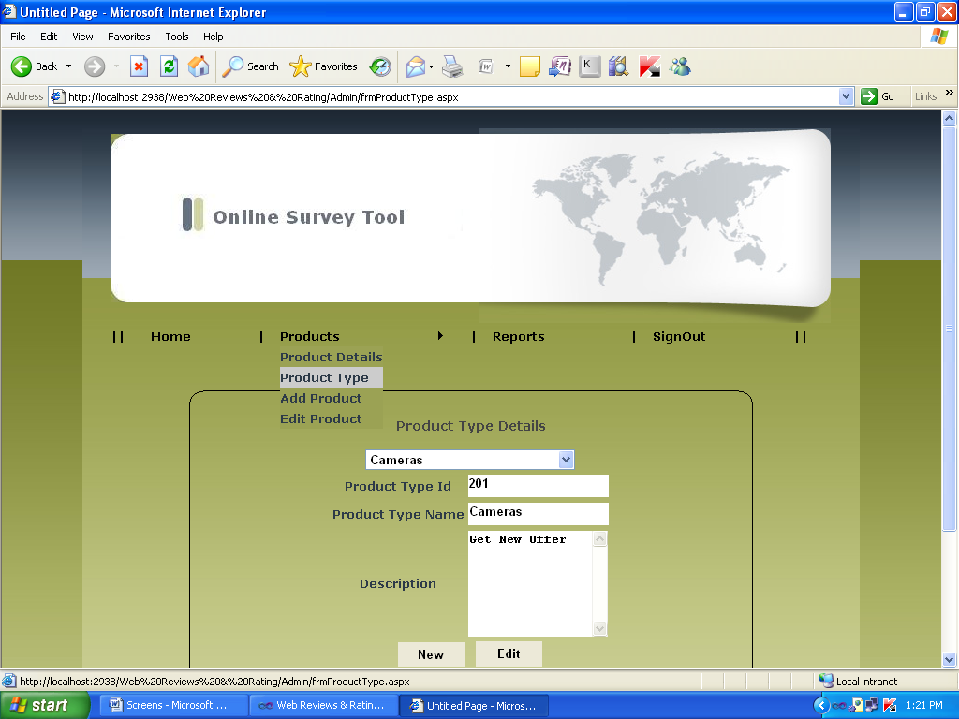

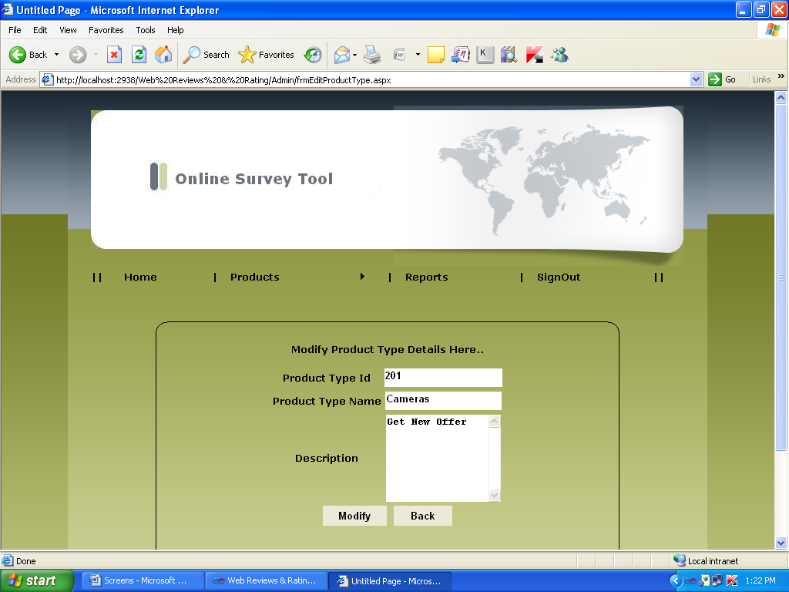

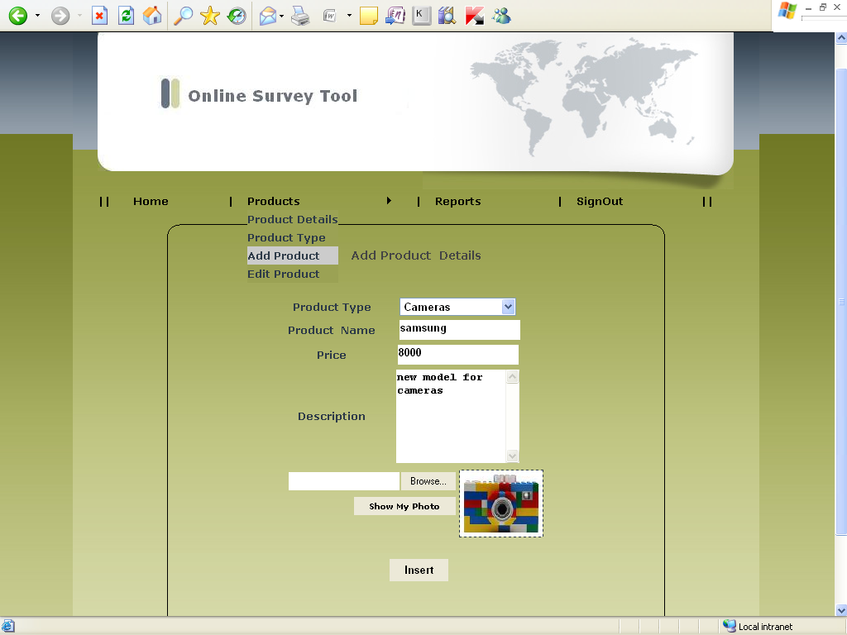

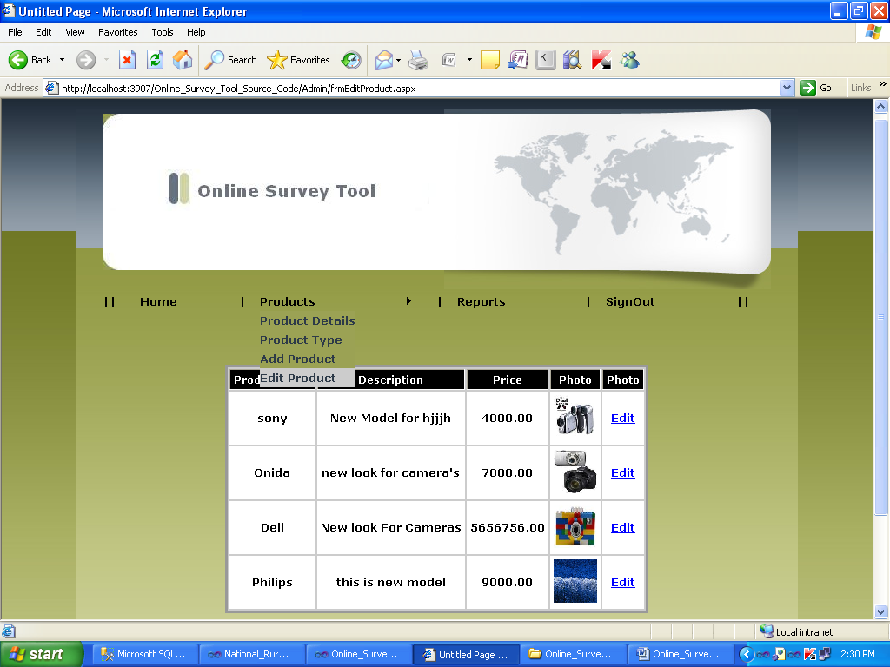

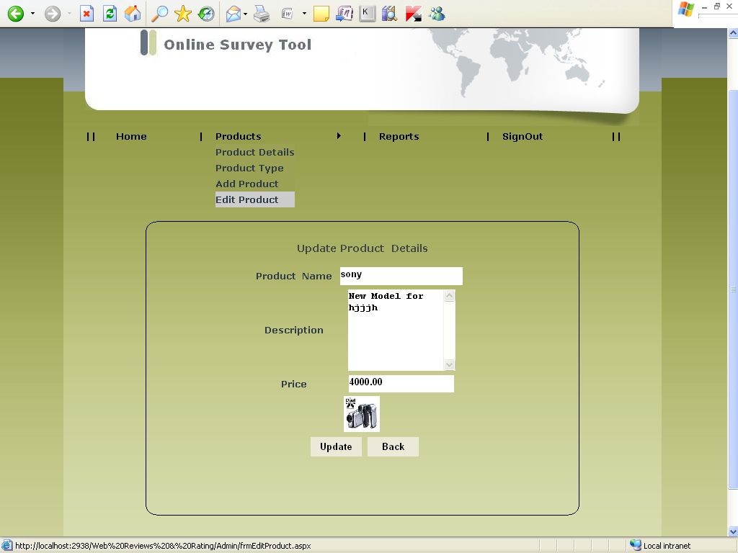
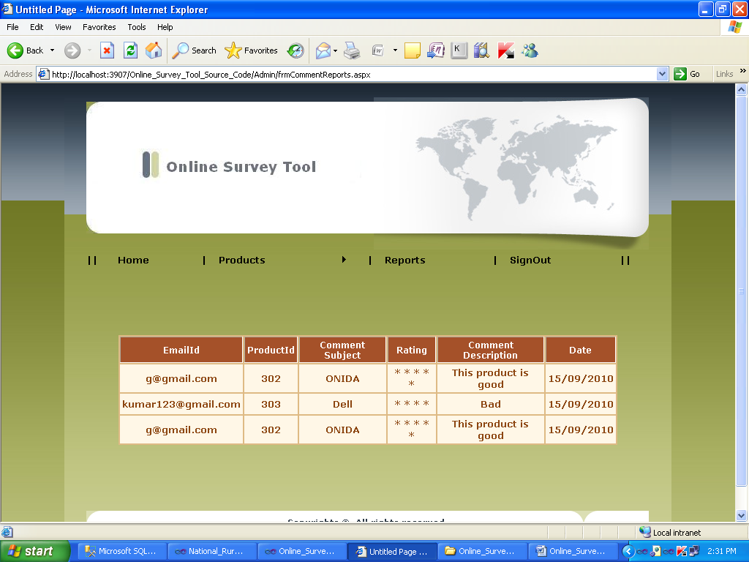

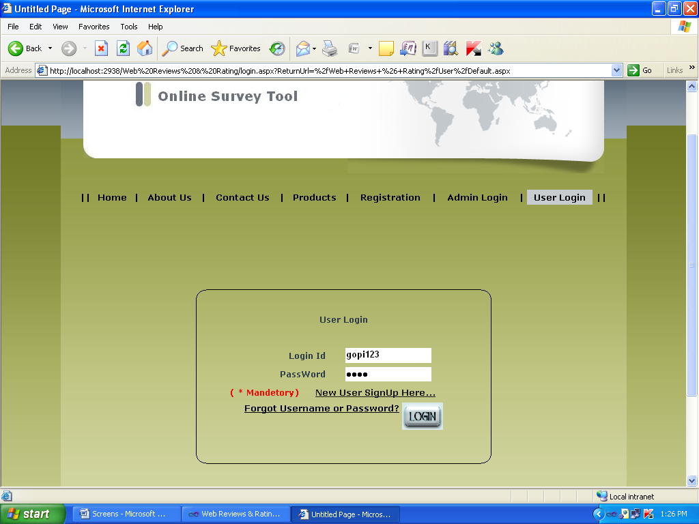

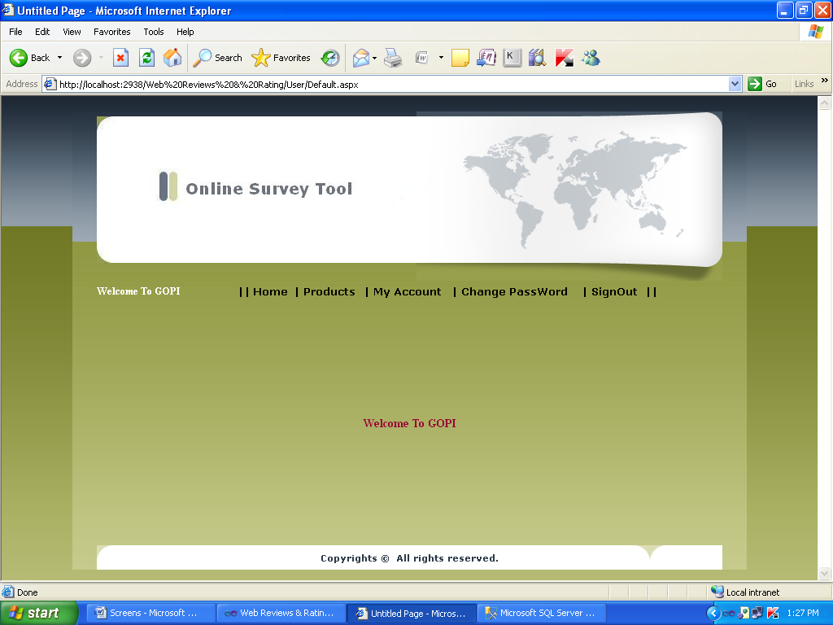

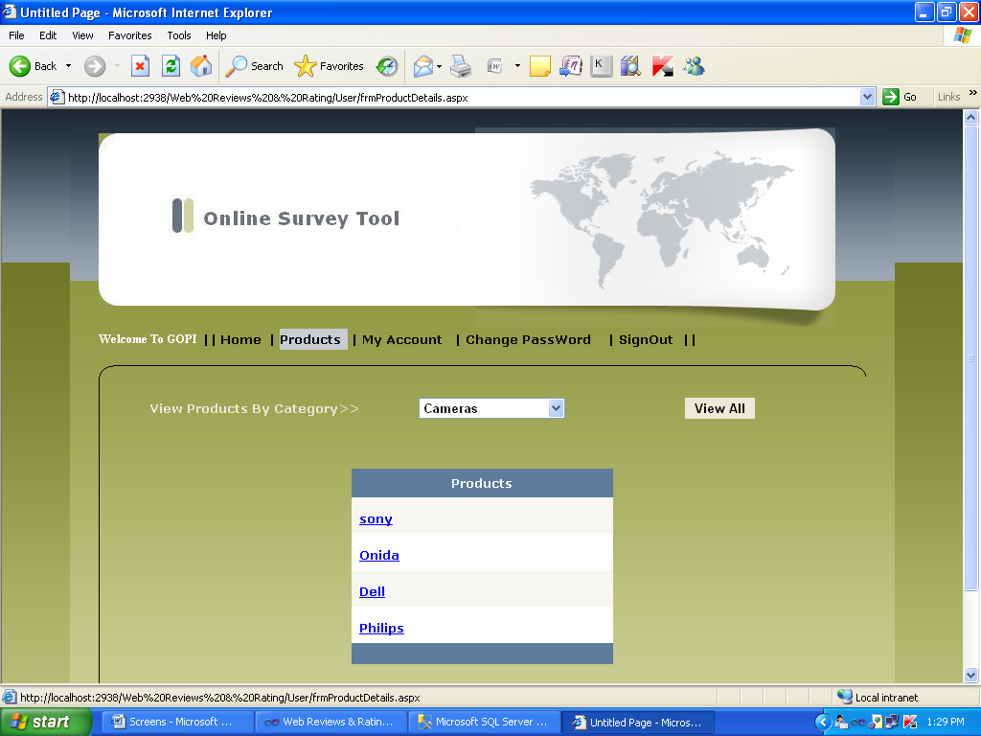

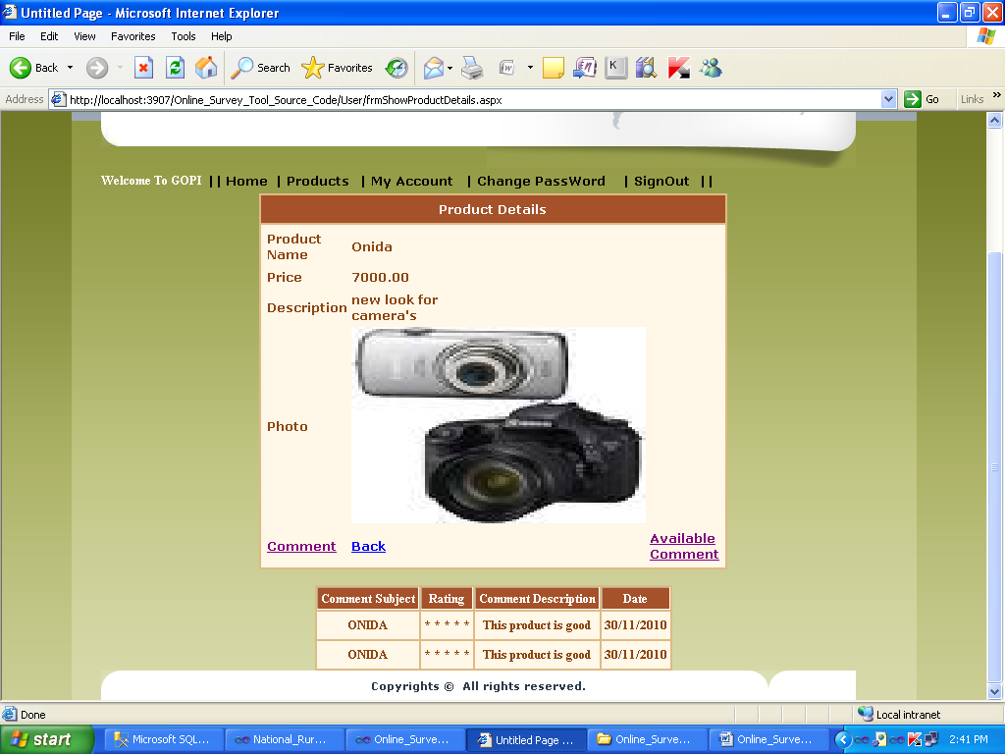
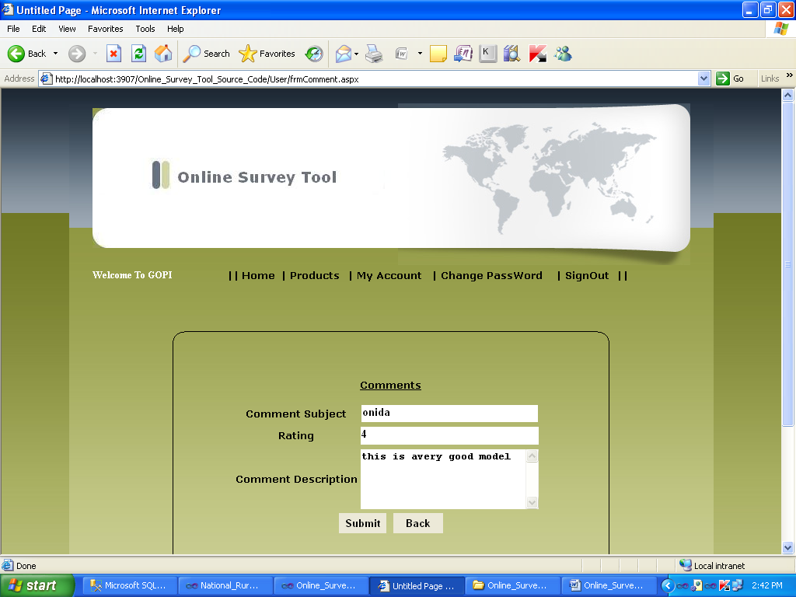
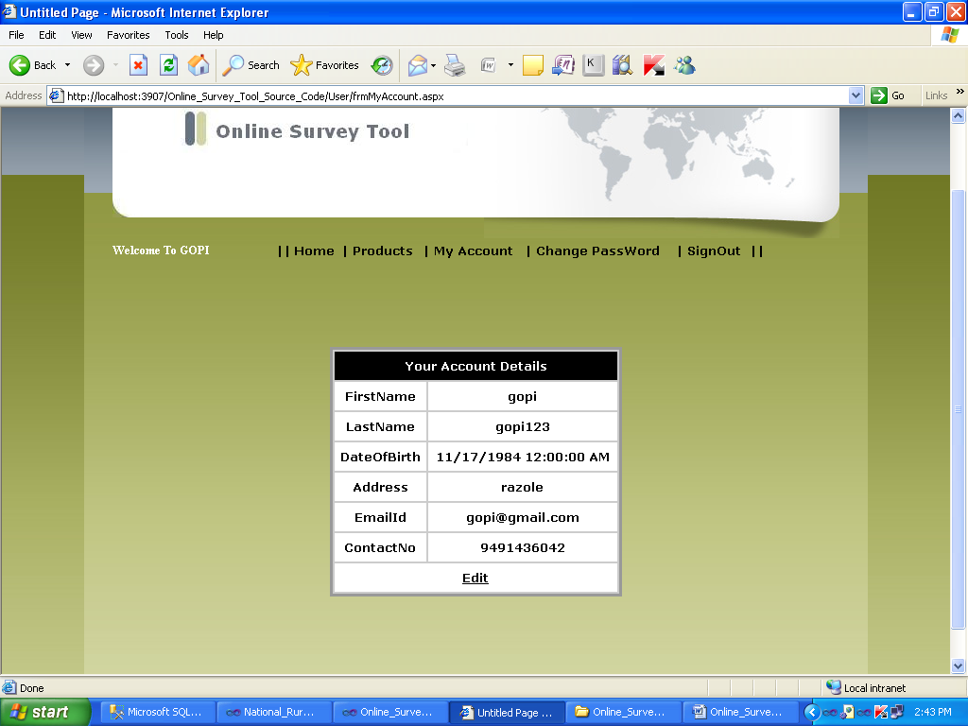

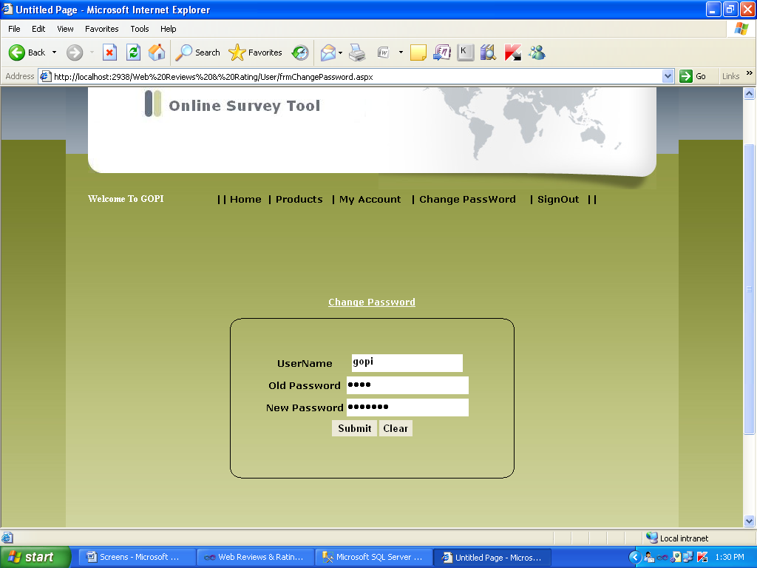

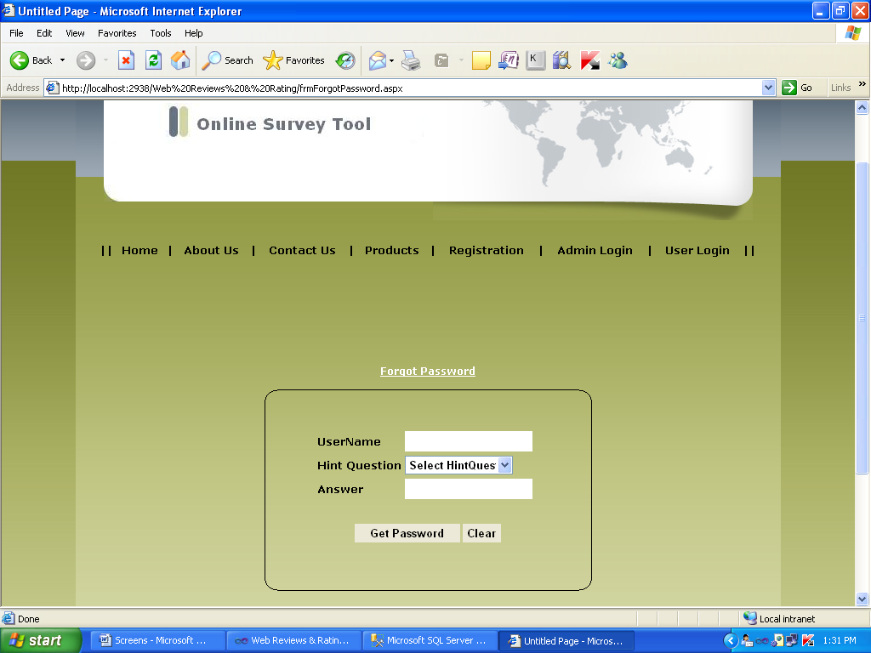

SYSTEM TESTING AND IMPLEMENTATION

  - INTRODUCTION
Software testing is a critical element of software quality assurance and represents the ultimate review of specification, design and coding. In fact, testing is the one step in the software engineering process that could be viewed as destructive rather than constructive.
A strategy for software testing integrates software test case design methods into a well-planned series of steps that result in the successful construction of software. Testing is the set of activities that can be planned in advance and conducted systematically. The underlying motivation of program testing is to affirm software quality with methods that can economically and effectively apply to both strategic to both large and small-scale systems.
8.2. STRATEGIC APPROACH TO SOFTWARE TESTING
The software engineering process can be viewed as a spiral. Initially system engineering defines the role of software and leads to software requirement analysis where the information domain, functions, behavior, performance, constraints and validation criteria for software are established. Moving inward along the spiral, we come to design and finally to coding. To develop computer software we spiral in along streamlines that decrease the level of abstraction on each turn.
A strategy for software testing may also be viewed in the context of the spiral. Unit testing begins at the vertex of the spiral and concentrates on each unit of the software as implemented in source code. Testing progress by moving outward along the spiral to integration testing, where the focus is on the design and the construction of the software architecture. Talking another turn on outward on the spiral we encounter validation testing where requirements established as part of software requirements analysis are validated against the software that has been constructed. Finally we arrive at system testing, where the software and other system elements are tested as a whole.

UNIT TESTING

MODULE TESTING

SUB-SYSTEM TESING

SYSTEM TESTING

ACCEPTANCE TESTING
Component Testing
Integration Testing
User Testing

8.3. UNIT TESTING
Unit testing focuses verification effort on the smallest unit of software design, the module. The unit testing we have is white box oriented and some modules the steps are conducted in parallel.
1. WHITE BOX TESTING
This type of testing ensures that
- All independent paths have been exercised at least once
- All logical decisions have been exercised on their true and false sides
- All loops are executed at their boundaries and within their operational bounds
- All internal data structures have been exercised to assure their validity.
To follow the concept of white box testing we have tested each form .we have created independently to verify that Data flow is correct, All conditions are exercised to check their validity, All loops are executed on their boundaries.

2. BASIC PATH TESTING
Established technique of flow graph with Cyclomatic complexity was used to derive test cases for all the functions. The main steps in deriving test cases were:
Use the design of the code and draw correspondent flow graph.
Determine the Cyclomatic complexity of resultant flow graph, using formula:
V(G)=E-N+2 or
V(G)=P+1 or
V(G)=Number Of Regions
Where V(G) is Cyclomatic complexity,
E is the number of edges,
N is the number of flow graph nodes,
P is the number of predicate nodes.
Determine the basis of set of linearly independent paths.

3. CONDITIONAL TESTING
In this part of the testing each of the conditions were tested to both true and false aspects. And all the resulting paths were tested. So that each path that may be generate on particular condition is traced to uncover any possible errors.
4. DATA FLOW TESTING
This type of testing selects the path of the program according to the location of definition and use of variables. This kind of testing was used only when some local variable were declared. The definition-use chain method was used in this type of testing. These were particularly useful in nested statements.
5. LOOP TESTING
In this type of testing all the loops are tested to all the limits possible. The following exercise was adopted for all loops:
All the loops were tested at their limits, just above them and just below them.
All the loops were skipped at least once.
For nested loops test the inner most loop first and then work outwards.
For concatenated loops the values of dependent loops were set with the help of connected loop.
Unstructured loops were resolved into nested loops or concatenated loops and tested as above.
Each unit has been separately tested by the development team itself and all the input have been validated.

SYSTEM SECURITY

9.1 INTRODUCTION
The protection of computer based resources that includes hardware, software, data, procedures and people against unauthorized use or natural
Disaster is known as System Security.
System Security can be divided into four related issues:
- Security
- Integrity
- Privacy
- Confidentiality
SYSTEM SECURITY refers to the technical innovations and procedures applied to the hardware and operation systems to protect against deliberate or accidental damage from a defined threat.
DATA SECURITY is the protection of data from loss, disclosure, modification and destruction.
SYSTEM INTEGRITY refers to the power functioning of hardware and programs, appropriate physical security and safety against external threats such as eavesdropping and wiretapping.
PRIVACY defines the rights of the user or organizations to determine what information they are willing to share with or accept from others and how the organization can be protected against unwelcome, unfair or excessive dissemination of information about it.
CONFIDENTIALITY is a special status given to sensitive information in a database to minimize the possible invasion of privacy. It is an attribute of information that characterizes its need for protection.
9.3 SECURITY SOFTWARE
System security refers to various validations on data in form of checks and controls to avoid the system from failing. It is always important to ensure that only valid data is entered and only valid operations are performed on the system. The system employees two types of checks and controls:
CLIENT SIDE VALIDATION
Various client side validations are used to ensure on the client side that only valid data is entered. Client side validation saves server time and load to handle invalid data. Some checks imposed are:
- VBScript in used to ensure those required fields are filled with suitable data only. Maximum lengths of the fields of the forms are appropriately defined.
- Forms cannot be submitted without filling up the mandatory data so that manual mistakes of submitting empty fields that are mandatory can be sorted out at the client side to save the server time and load.
- Tab-indexes are set according to the need and taking into account the ease of user while working with the system.

SERVER SIDE VALIDATION
Some checks cannot be applied at client side. Server side checks are necessary to save the system from failing and intimating the user that some invalid operation has been performed or the performed operation is restricted. Some of the server side checks imposed is:
- Server side constraint has been imposed to check for the validity of primary key and foreign key. A primary key value cannot be duplicated. Any attempt to duplicate the primary value results into a message intimating the user about those values through the forms using foreign key can be updated only of the existing foreign key values.

- User is intimating through appropriate messages about the successful operations or exceptions occurring at server side.
- Various Access Control Mechanisms have been built so that one user may not agitate upon another. Access permissions to various types of users are controlled according to the organizational structure. Only permitted users can log on to the system and can have access according to their category. User- name, passwords and permissions are controlled o the server side.

- Using server side validation, constraints on several restricted operations are imposed.

CONCLUSION

It has been a great pleasure for me to work on this exciting and challenging project. This project proved good for me as it provided practical knowledge of not only programming in ASP.NET and C#.Net web based application and no some extent Windows Application and SQL Server, but also about all handling procedure related with “Online Survey Tool”. It also provides knowledge about the latest technology used in developing web enabled application and client server technology that will be great demand in future. This will provide better opportunities and guidance in future in developing projects independently.
BENEFITS:
The project is identified by the merits of the system offered to the user. The merits of this project are as follows: -
- It’s a web-enabled project.
- This project offers user to enter the data through simple and interactive forms. This is very helpful for the client to enter the desired information through so much simplicity.
- The user is mainly more concerned about the validity of the data, whatever he is entering. There are checks on every stages of any new creation, data entry or updation so that the user cannot enter the invalid data, which can create problems at later date.
- Sometimes the user finds in the later stages of using project that he needs to update some of the information that he entered earlier. There are options for him by which he can update the records. Moreover there is restriction for his that he cannot change the primary data field. This keeps the validity of the data to longer extent.
- User is provided the option of monitoring the records he entered earlier. He can see the desired records with the variety of options provided by him.
- From every part of the project the user is provided with the links through framing so that he can go from one option of the project to other as per the requirement. This is bound to be simple and very friendly as per the user is concerned. That is, we can sat that the project is user friendly which is one of the primary concerns of any good project.
- Data storage and retrieval will become faster and easier to maintain because data is stored in a systematic manner and in a single database.
- Decision making process would be greatly enhanced because of faster processing of information since data collection from information available on computer takes much less time then manual system.
- Allocating of sample results becomes much faster because at a time the user can see the records of last years.
- Easier and faster data transfer through latest technology associated with the computer and communication.
- Through these features it will increase the efficiency, accuracy and transparency

LIMITATIONS:
- The size of the database increases day-by-day, increasing the load on the database back up and data maintenance activity.
- Training for simple computer operations is necessary for the users working on the system.

FUTURE IMPROVEMENT

- It can be implemented to upload files with an huge amount of size with the support of various file formats.

- This System being web-based and an undertaking of Cyber Security Division, needs to be thoroughly tested to find out any security gaps.

- A console for the data centre may be made available to allow the personnel to monitor on the sites which were cleared for hosting during a particular period.

- Moreover, it is just a beginning; further the system may be utilized in various other types of auditing operation viz. Network auditing or similar process/workflow based applications...

BIBLIOGRAPHY

- FOR .NET INSTALLATION
www.support.mircosoft.com
- FOR DEPLOYMENT AND PACKING ON SERVER
www.developer.com
www.15seconds.com
- FOR SQL
www.msdn.microsoft.com
- FOR ASP.NET
Asp.Net 3.5 Unleashed
www.msdn.microsoft.com/net/quickstart/aspplus/default.com
www.asp.net
www.fmexpense.com/quickstart/aspplus/default.com
www.asptoday.com
www.aspfree.com
www.4guysfromrolla.com/index.aspx
- Software Engineering (Roger’s Pressman)

